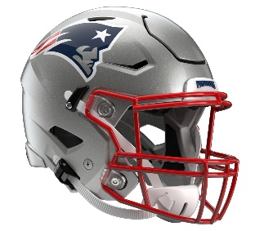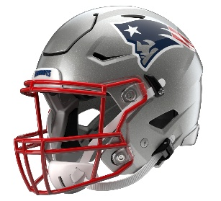

New England Patriots
Postgame Transcript
October 18, 2026

PATRIOTS HEAD COACH MIKE VRABEL
POSTGAME PRESS CONFERENCE
October 18, 2026

Q: Just your overall thoughts on the win.

MV: We're lucky to win, is probably where I'd start, but we're happy that we won. We'll enjoy it for about an hour, and then we're going to focus on the next task.

Q: When you say lucky, can you expand on that?

MV: Fortunate, whatever. We just didn't play very well. We tried to beat ourselves, but we made enough plays in critical situations to help us get through here today.

Q: Coach, in this league, a win is a win regardless of how you get it. How does a win like this help you moving forward, a tight game like this?

MV: We won't know until we move forward, but I just know that you have to be able to continue to improve, and I don't feel like we did. We won, which is the most important thing. We just, I don't think we improved from what we had shown the previous two weeks, and I have to figure out why. That's my job. My job's also to get us to win and also to get us to improve.

Q: Mike, what made you guys lean on Corey Kiner at the end of the game over Rhamondre Stevenson?

MV: He runs hard. He runs hard, and it's the same way he's selling the kickoff returns. We got three capable backs and you ride the hot hand. So should we have not rode him? Okay, good. I just was curious.

Q: Hi, Mike. I'm curious, with A.J. [Brown], just what did you see from him in his first game back?

MV: I think he could’ve probably made a few more plays, come down with a few more plays. He's been out for a while. I know that he wanted to do well for his football team, and unfortunately it wasn't his best effort. I know that he knows that, and we have all the confidence in the world in A.J. just to be able to finish those plays. I think that play Rome [Doubs] made looking back at it is one of the huge plays of this football game, and unfortunately he wasn't able to return. But to be able to hang on to that football, I give him a lot of credit. But A.J. has high expectations for himself, and we have high expectations for him as well. So, I'm confident that he'll come back and do a lot of things that help us here the rest of the season.

Q: Mike, the offensive line, the guys that stepped in, Caleb [Lomu], Matt [Pryor], Walter [Rouse], just your thoughts on that.

MV: We were able to run the football. We were able to protect the quarterback. I felt like we really gained some energy, and that was impressive to go that long and get the ball down there. I wish we would've converted. We didn't, but I think that's just those guys were ready for their opportunity, and it was great to see. I just, you never know what's going to happen in this league, and we talk about it all the time, preparing for the journey. When guys get their chance, they go in there and perform. I hate that we don't have the guys. I hate when guys get injured, but I also understand that on the other side of that, there's an opportunity.

Q: Mike, you guys went from not having A.J. Brown for four weeks to now he's your leading receiver today, 10 targets. It seemed like there were some plays drawn up for him. In trying to work him back in, are you concerned that that's maybe affecting the flow of the offense a little bit?

MV: No, I think he has to make the catches when we throw to him, and no, I don't see that being -- the plays that are drawn up, I don't think that -- I think there's a progression in everything that we do. Maybe if we have a play that's designed to go to him and it's clouded, then it goes somewhere else. But maybe the play that ended up with Pop [DeMario Douglas] was supposed to go to AJ. I don't think that that hurt us until we fumbled the football. So, I think there'll be times where you want to try to put your best players at the point of attack. If it's not there, the quarterback has to know, 'Hey, they did something that took that away, much like you try to get guys on defense to get them in the right position.' So, I think just make the plays that you're supposed to make, and that goes for all of us. That starts with me being great and doing what I need to do to help this team win. Then that has to translate all the way down.

Q: Mike, after the Seattle game, I think Drake Maye said he lost patience in that game. Today, they didn't blitz him as much. There were times where they dropped eight. Is that a sign of his growth that he didn't force things and sort of played with things in front of him?

MV: I think so, that we just -- and they'd shown a lot of pressure coming in, and I think they mixed it in at times, certainly there to start the second half. But I think Drake Maye continues to stay very even-keeled. I think that he probably is much more mature than I probably think in my head, just being 24. But I think that he is very even-keeled. I think seeing him operate in that five-minute situation, communicate with those guys and explain to them what we were going to do and how we were going to try to operate, I was, again, none of us were at our best today. But he was certainly good enough and was able to find Rome, find Hunter [Henry], be patient and not get jittery.

Q: Mike, how big has your depth been to start this season over the first six weeks, and how can playing so many backups help you later down the line this season?

MV: Just try to get the guys ready. I think that that's something that we targeted. We knew that it was probably unique to add 10 players at the end of training camp that were new, and there was going to be some growing pains getting those guys ready. But I think that when you look at [Cameron] Latu, [Erick] Hunter, Moose [Darius Muasau] and those guys contributing in a way that they did on special teams, that kickoff unit was fun to watch. That probably was our best unit today in all the phases. So, that was fun to watch. Fun to see Corey Kiner, a guy that we added, make plays in kickoff return and offense, and Walter, who we added, and Pryor. So, it takes a little bit of time to get those guys brought up to speed. But then certainly I enjoy watching those guys go out and take advantage of their opportunity. They go from sitting there as a backup not knowing whether they're going to be in the game to contributing to us winning. So, that's exciting.

Q: Just the guys who left here today, is there anything you can share about whether it's Romeo Doubs or AVT (Alijah Vera-Tucker) that might be available for Thursday or might be unavailable?

MV: I mean, again, listen, we are all smart people here, some smarter than others. But it's a short week. So, whether they can make it back or not, I don't know. They don't finish the game. We'll have to see, but I don't know any other thing other than that. And we'll just have to figure out who we have available and find 48 to put out there. So, it's just hard to say, but it's a short week, and if you don't finish the game, that's a quick turnaround.

Transcripts are provided by the Patriots media relations department as a courtesy to the media and are edited for readability. All press conferences are posted and archived in their entirety on patriots.com. The duplication or posting of this transcript in its entirety as original content is prohibited. Media are encouraged to link to the complete transcript on patriots.com when sharing full quotes with their audiences.

MEDIA RESOURCES
Schedule | Roster | Videos | Photos | Audio | Media Website | Twitter | Facebook | Instagram
Social: @Patriots | #PatriotsNation
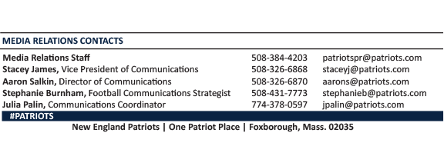
--PATRIOTS--

