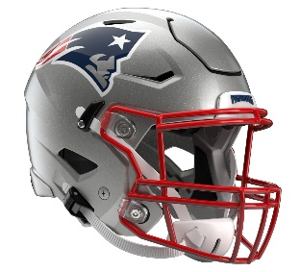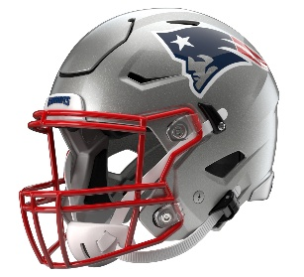

New England Patriots
Postgame Transcript
October 18, 2026

PATRIOTS QUARTERBACK DRAKE MAYE
POSTGAME PRESS CONFERENCE
October 18, 2026

Q: Coach [Mike] Vrabel wasn't overly pleased, said you guys were lucky to win, and he didn't feel that you guys had advanced from your previous game. How did you feel?

DM: I think Coach has a great perspective on how we feel like we've attacked the week and put the results into the game. I feel like we weren't -- it was sloppy, it wasn't clean. It wasn't football that we felt like -- we weren't complimentary. We weren't protecting the football on offense. It took us a while to get into a rhythm. We had the first drive that we didn't get anything going. Then we had a one-play touchdown, which was kind of weird, so we weren't out there very long. Then we just kept on doing ourselves in, hurting ourselves. From there, I think it's hard. Coach always says you've got to take wins in this league and enjoy them, and at the same time, realize we won, but it wasn't how we want to accomplish [that].

Q: Drake, when it comes to your performance, it seemed very efficient. Again, no turnovers. What has gone right for you over the last three weeks, and why do you feel that your play has picked up so much?

DM: Yeah, I think trusting what I see on film, trusting what I'm communicating to guys in the huddle, what we're doing in the passing game, what we're trying to get into, good run checks, trusting Coach [Josh] McDaniels, our communication and our relationship, and then just trusting what I'm seeing. I feel like I'm seeing it well and trying to throw it to the open guy. I missed a few times today, and sometimes -- the one to Pop [DeMario Douglas], missed high. A.J. [Brown], missed low a couple of times. So, I've got to do my part, and then from there let those guys run and make plays, and they were doing that today.

Q: Drake, after that first game this year, you said you lost some patience in that game. Flash forward, there were times where they dropped eight, there were times where they just rushed four, and they were trying to muddle you and keep you in the pocket, and yet you remained patient. Is that just part of the growth of the quarterback and seeing what you're seeing and being confident in it?

DM: Yeah, I think so. I think that's for me. I'm naturally -- I always tell my wife since I got married, I've never sat on the couch and watched the most TV. I've grown up with brothers and always want to be on the move and just be doing something, not just hanging around. So, it's kind of the same thing in the pocket. I feel like I've got time. I'm still a little bit antsy in there and antsy to move. I feel like at times last year, I kind of moved out of clean pockets a lot of times and was trying to make some plays on the move. I felt like when I got time in there the past two weeks, we've had two good plays when I've sat in there and just kind of kept my eyes downfield. I always feel like Coach McDaniels credits some quarterbacks he's had in the past, especially when they see droppers and just be patient back there.

Q: On the same lines there, did they blitz a little less than you guys were expecting? It didn't seem to blitz you much. And just on the [Romeo] Doubs touchdown, can you just take us through that play at the drop eight?

DM: Yeah, really the first half, we expected more, but I think they ramped it up in the second half. They made some plays, or kind of made some run-throughs. I missed some protection things that I've got to do a better job of. But yeah, Romeo made a great catch. I kind of sat in the pocket. I think they rushed maybe three, and they dropped. I think they may have had miscommunication, what it seemed like to me. I had A.J. over the middle late, and I just don't want to throw over the middle late, so I kind of just saw Romeo throw the hand up and start running, so I tried to give him a ball to catch. I hate -- I could've put it more on him and not have him dive, and then he goes down. So, those are things that I care about that I'm mad at, but it's football.

Q: They had 8sacks last week, but today they had 0, despite all the injuries and rotations on your offensive line.

DM: Clap. Clap it up in there, yes, sir.

Q: So, how important is it to keep your offensive flow going, and what's the key behind that?

DM: Yeah, I said I've got to bring in some more treats. Shout out to Ann Michael [Maye]. I've got to keep on bringing some more treats. Those guys are doing a heck of a job in there. Coach Doug [Marrone] and Coach Hoss [Jason Houghtaling], they're coaching them hard. They're expecting a lot in practice, and those guys are playing through injuries. We had three go down today, so these guys are fighting hard. They're fighting their butts off, and it goes through them. That last drive running the football, you all got the best seat in the house. It was beautiful to see. I think the more we can do that, the more we can just gel together as offense and lean on that.

Q: How would you describe where the connection is with A.J. coming off this game?

DM: Yeah, I think it was, first of all, it was great to see him back out there. It was cool to see a different guy in the huddle. Man, he looks cool in the huddle. So, I'm looking forward to just growing, just building the connection. I think there's some me, there's some, obviously, plays he wish he had back, but man, I tell him, I was just telling him in the locker room, "Man, you ain't got to worry about No. 1." He's a player in this league. He's going to be one of the best players on the field every time he steps on it. I told him I'm going to keep coming his way, and I don't really think there's too much to say about it. He's a great player. He's got great hands. He's got great releases, and he was open today. I thought he looked good running around, and I'm glad to have him back, and I'm looking forward to seeing him down the road. It'll be fun.

Transcripts are provided by the Patriots media relations department as a courtesy to the media and are edited for readability. All press conferences are posted and archived in their entirety on patriots.com. The duplication or posting of this transcript in its entirety as original content is prohibited. Media are encouraged to link to the complete transcript on patriots.com when sharing full quotes with their audiences.

MEDIA RESOURCES
Schedule | Roster | Videos | Photos | Audio | Media Website | Twitter | Facebook | Instagram
Social: @Patriots | #PatriotsNation
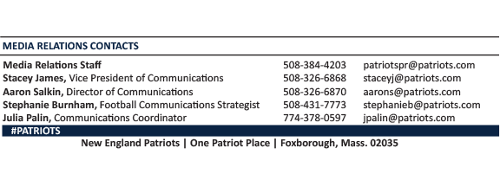
--PATRIOTS--

