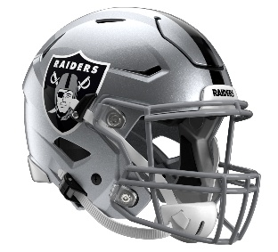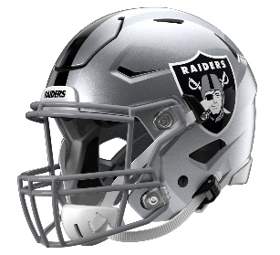

Las Vegas Raiders
Postgame Transcript
October 11, 2026

RAIDERS HEAD COACH KLINT KUBIAK
POSTGAME PRESS CONFERENCE
October 11, 2026

KK: Very disappointing performance today from everyone, players and coaches. Obviously give a lot of credit to the Patriots. They did a great job. We had eight penalties today; far too many. It's a game that we have to move forward from very quickly. We have everything ahead of us as a team. We're not happy with what happened today, and we have to go do something about it. We have to fix it and move on, so I'll take any of your questions.

Q: As a whole, what went wrong with the defense today?

KK: Well, defensively, offensively, special teams, I don't think any of us played well enough to win today. Credit to the Patriots; they did a great job.

Q: Can you pinpoint a reason why the team came out flat today?

KK: It's on me to get us ready to go, and we weren't ready to go.

Q: Mike Washington Jr. only had one carry. What kind of led to that?

KK: Well, playing from behind the whole game - there was plenty of opportunities to get him in later in the game, but it was a passing game. Early in the game, especially, I needed to stay with the run. Okay? Didn't need to abandon it so fast. So, that's on me.

Q: You brought up the penalties. You had been pretty clean playing over the first four weeks. What did you see the reason for the penalties today?

KK: Yeah, I'll have to go back and look at each individual one, but that's not up to our standard.

Q: What went into the decision to have [Fernando] Mendoza came out there on that final drive?

KK: Yeah, just wanted to get him some exposure.

Q: How did you think he handled everything?

KK: He did a good job. Yeah, he did a good job.

Q: How do you think that can help him, getting game action can help him with his development going forward?

KK: Yeah, all reps are valuable. Very important for him.

Q: What do you feel like went wrong with the running game again today?

KK: Well, I think just overall today, we were playing from behind all day, so it became a passing game, and it didn't need to be that way. I abandoned the run game too early and didn't give it a chance to get going.

Q: What do you think were some of the issues that came up with protecting Kirk [Cousins]?

KK: Well, they did a great job in their blitz package. When you pass it that many times, there's going to be those. But overall, I think they did a great job of pressuring us today.

Q: It felt like there were a handful of situations where your cornerbacks were in one-on-one coverage against guys. Was that the plan coming in, to be aggressive in that regard? Did you guys make any adjustments to that?

KK: Well, obviously not. They kept going after us and they made big plays. Credit to them.

Q: What was the reason with subbing Zeke [Hezekiah Masses] and Darien [Porter] in and out?

KK: That was the plan going in. We wanted to get both guys on the field.

Q: There was some special teams mistakes as well, in all three phases but specifically special teams, did that surprise you a little bit today?

KK: Yeah, it did. That's been a strength of our team. I see it as a strength moving forward. We have to go to work to get it fixed.

Q: Down 14-7 in the second quarter, you ran that toss play to Tre [Tucker] that resulted in a loss. How much do you feel like that was a big momentum swing?

KK: That was a huge moment. Trying to make an aggressive play, their defensive end made a great play and sniffed it out. Took a big negative loss there. That was a big play in the game.

Q: Do you feel like you need more production out of your wide receivers?

KK: I just think overall as a team, we just all have to be better, coaches and players.

Q: Do you feel that Ashton [Jeanty] was still hampered by injury at all today?

KK: Yeah, I think everyone is beat up. That's the league. Yes, Ashton is beat up, and that's a testament to how tough he is, that he's out there today playing for his teammates.

Q: I'm assuming Mendoza being out there doesn't change anything with your plan at quarterback?

KK: It does not, no.

Q: It seemed like you had a mismatch with Brock [Bowers] against some of their DBs. Do you feel like you could have exploited that a little bit more today?

KK: Yeah, I think we did not get it done as a staff, as an offense today.

Q: It goes without saying, but the negative plays and the penalties put you guys behind the sticks. From a play caller's standpoint, how difficult is that to overcome?

KK: Yeah, second-and-long, third-and-long, that's advantage defense every time.

Q: Nick Saban talks about rat poisoning when you start to do some things. Do you think there was any element of that, just that this is a young team learning how to become a winner?

KK: Well, I think it's going to show a lot about who we are, how mature we are, how good our leadership is with myself, for our players. It's an opportunity for us to move forward. We have our whole season ahead of us, and we can't let this game beat us twice.

Q: What's the message to the team going forward, trying to put this game behind you?

KK: Yeah, what I told the guys is, what makes you a loser is if you're pointing fingers at other people. We're all trying to look interior, looking at what we can do better and move forward.

Q: Does it feel like you got that response when you were with the team now?

KK: Yeah. I love our guys. I love our guys, and we didn't get it done as a group today. I know that they're going to be ready to compete moving forward.

Q: It didn't seem like the pass rush was getting home on Drake [Maye] today. Where do you think it can affect the quarterback?

KK: Credit to New England; they protected well. They threw the ball down the field really well.

Transcripts are provided by the Patriots media relations department as a courtesy to the media and are edited for readability. All press conferences are posted and archived in their entirety on patriots.com. The duplication or posting of this transcript in its entirety as original content is prohibited. Media are encouraged to link to the complete transcript on patriots.com when sharing full quotes with their audiences.

MEDIA RESOURCES
Schedule | Roster | Videos | Photos | Audio | Media Website | Twitter | Facebook | Instagram
Social: @Patriots | #PatriotsNation
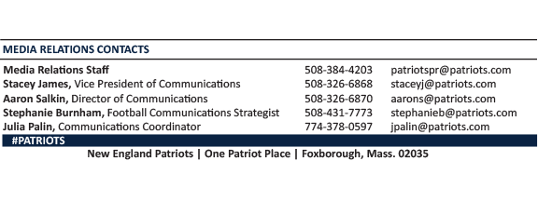
--PATRIOTS--

