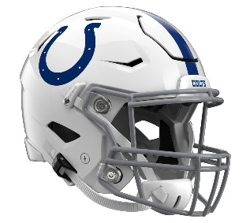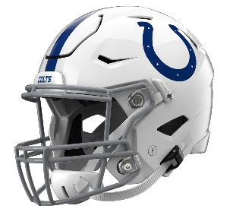

Indianapolis Colts
Postgame Transcript
August 13, 2026

COLTS HEAD COACH SHANE STEICHEN
POSTGAME PRESS CONFERENCE
August 13, 2026

SS: All right, I'll start with just injuries. Jaylon Jones, he's being evaluated for concussion, and [Luke] Tenuta had a knee. I thought overall, just the week in general, I thought we got some really good work in this week, obviously the joint practice. And then today, I was pleased with our guys' effort out there. There's some good, but a lot to clean up as well. So, ready when you guys are.

Q: Shane, what happened with Brian [Mason] there at the end of the game?

SS: He got rolled up right on the sideline on that last play. So, we'll see. He's getting evaluated for his knee right now.

Q: Shane, your thoughts on what you saw from AR [Anthony Richardson] early on in the game?

SS: He did some good things. Obviously, we're moving the ball efficiently. Obviously, the turnovers hurt us there, the fumble down there. We had two fumbles in the red zone, an INT with your two picks, it's hard to maintain drives when you're turning the ball over. But overall, I thought he did a lot of good things.

Q: His ability to bounce back after that kind of rough first series, just what did that show you about him in this today?

SS: Yeah, it was huge. I think even the two-minute drive at the end of the half was big to get us down there. So, he did a lot of good things. He threw it well. I think he had a good completion percentage. He was going to the right spots with the ball.

Q: The [Seth] McGowan fumble, did you think he got in? It felt like they let that play go away.

SS: Yeah, it looked like it, but I'm not the official.

Q: So how, for a guy like Seth, who's competing for that number two spot, how do you evaluate that? Do you still have to hold all the way through the play?

SS: Yeah, it's not a have to have it situation. So, we have to hold on to the ball in that situation.

Q: What did it mean for Spencer [Shrader] to get that kick there at the end?

SS: It was big. Obviously, we wanted to work on some kicking with those two guys battling, and so for him to kick that long field goal was huge.

Q: Your thoughts on Caden Curry, what he was able to do? He was active throughout the night.

SS: Yeah, I think defensively, a lot of rookies, Caden Curry made a ton of plays. I was really pleased with him. Bryce Boettcher was flying around. [George] Gumbs [Jr.] made some plays. So, it was really good to see the young guys defensively, especially with the sudden change and the turnovers that we had offensively, to stop those guys was big.

Q: What did you think you saw from Riley [Leonard]? It felt like maybe, he's talked about needing to speed up the decision making. It felt like maybe he held it a little too long.

SS: Yeah, we'll go back. I think we had some batted balls on a few of those. And obviously, when you go back and evaluate the tape, just looking at the coverages, and they were covered or not covered. He did some good things, but things we need to clean up as well.

Transcripts are provided by the Patriots media relations department as a courtesy to the media and are edited for readability. All press conferences are posted and archived in their entirety on patriots.com. The duplication or posting of this transcript in its entirety as original content is prohibited. Media are encouraged to link to the complete transcript on patriots.com when sharing full quotes with their audiences.

MEDIA RESOURCES
Schedule | Roster | Videos | Photos | Audio | Media Website | Twitter | Facebook | Instagram
Social: @Patriots | #PatriotsNation
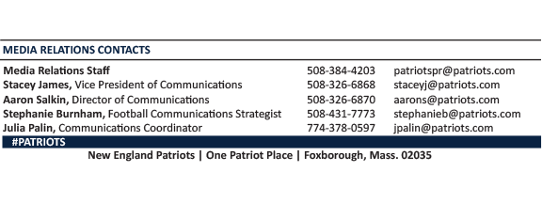
--PATRIOTS--

