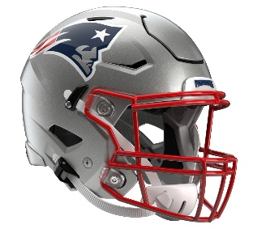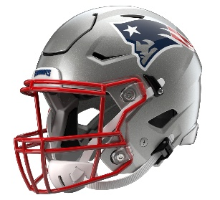

New England Patriots
Postgame Transcript
August 13, 2026

PATRIOTS QUARTERBACK BEHREN MORTON
PRESS CONFERENCE
August 13, 2026

Q: Did you have anyone supporting you here today? Who might that be? And what were your thoughts on the fans at the end of the game?

BM: Yeah, so my mom came, my sister came, and my fiancée came down. My fiancée moved up here, actually today, so she’s up here now. Today was awesome. The fans and atmosphere were great. Getting to play at a stadium like this, that we call home now, is really cool. And I really had a lot of fun today, enjoyed it.

Q: Behren, in terms of your own development, what things are you trying to show? Obviously, you are trying to show how to run the plays and throw the football, but what things are you trying to show to your teammates, in terms of command of the huddle, and especially at the end there where you were running some tempo as well?

BM: Yeah. I think that it reverts back to what we’ve been through this fall camp, trying to prove a point to be on this team. I think if you show you know what you are doing, that shows respect from the veterans. So, just taking it one day at a time, too, not getting ahead of yourself. Today was awesome, getting to go out with those guys that we’ve been getting a lot of reps with. You go out there and go play against someone else; it was a lot of fun. But there’s a lot to correct, for sure. So, it’s just a starting block for us, and we have two more games, so we’ve got to look forward to that.

Q: Behren, did you have a moment where you soaked it in, in that first NFL game in an NFL stadium? How good did you feel about the drive at the end to set up Andy [Borregales] for the attempt for the game-winning field goal, to be able to accomplish what you wanted to do to get you guys in field goal position?

BM: Yeah, once we got out there for pregame, it was kind of a surreal moment. You’re playing at such a legendary place, so it was really cool to be there in that atmosphere. And then as the game went on, we just have got to be better on first and second down. We can’t have penalties that put us behind the chains, and it starts with me. So, being commander of the huddle, getting back to what’s next, what’s the next play, and let’s have a positive play. But we’re just trying to execute, we’re trying to do our job and put us in a good position.

Q: Going out for that potential game-winning drive at the end, was anything said by Drake [Maye] or Tommy [DeVito] before you took the field, in terms of just trying to calm you down or maybe find the right mindset going out there?

BM: Just take a deep breath, it’s just football, is what they said. And at the end of the day, it is just football. The ball is going to get spotted, and we had a minute and something left. So, it’s our job to do what we are supposed to do and move the ball down the field. We should’ve pushed the ball further down the field for Andy. But proud of the way that we responded. We got pretty sluggish in the third, sluggish in the fourth and finished off the fourth better.

Transcripts are provided by the Patriots media relations department as a courtesy to the media and are edited for readability. All press conferences are posted and archived in their entirety on patriots.com. The duplication or posting of this transcript in its entirety as original content is prohibited. Media are encouraged to link to the complete transcript on patriots.com when sharing full quotes with their audiences.

MEDIA RESOURCES
Schedule | Roster | Videos | Photos | Audio | Media Website | Twitter | Facebook | Instagram
Social: @Patriots | #PatriotsNation
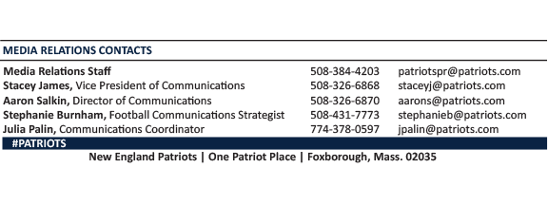
--PATRIOTS--

