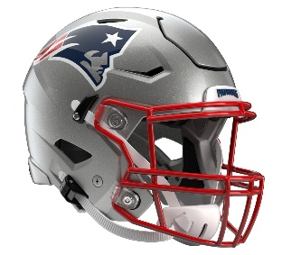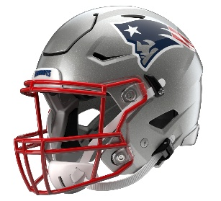

New England Patriots
Postgame Transcript
August 13, 2026

PATRIOTS HEAD COACH MIKE VRABEL
POSTGAME PRESS CONFERENCE
August 13, 2026

Q: Obviously, you had a lot of backups in your game. Was it good to see the defense produce four turnovers right out of the gate?

MV: I think they better have. I think they better have or there would have been a lot more points that they scored. The turnovers are great, and I love us attacking the football and taking advantage of that. Just a lot of things to clean up, but when you talk about the ability to create turnovers, it can change the game. Just try to defend every blade of grass down there on the goal line and come up with a big turnover there.

Q: Just kind of big picture, what you took from the week with the joint practice and then tonight?

MV: Yeah, it's good work. Hopefully, everybody came out as clean as possible. That's a good football team. They run the ball well, good up front and gave us multiple looks defensively throughout the practice. I felt like it was good to work with them and try to have a productive game.

Q: Just wondering when you knew Christian [Gonzalez] was not going to be here tonight and when you had that conversation.

MV: Christian was in a group of many players that weren't here tonight.

Q: On Terrell Jennings, we learned before the game he ended up on IR. Anything you can add to that? And a follow-up with Jam [Miller], what did you see from Jam tonight?

MV: Yeah, no follow up. We put guys on IR that are going to be out for an extended amount of time, and unfortunately, Terrell will be in that group. But it was good to see Jam come out and have some nice runs. I felt like he ran with his pads down and had a couple physical runs, and was happy for him. This is a great evaluation. We can start to figure out guys that can and start to figure out guys that can't, too.

Q: Andy [Borregales] missed a couple of field goals today. What was your message to him?

MV: Three. I don't have a message. We're expected to make them. That's pro football. They're banging them in from 60 yards. They’ve got two kickers on the roster, so Andy knows that we have to make those field goals.

Q: Just curious with Ben Brown, we saw him go down and then into the locker room. Do you have any update on him and what happened there?

MV: No, he wasn't able to return, unfortunately. We'll evaluate, hopefully know more in the morning. I don't think it's anything too serious, but I also don't want to speculate until we're able to do some more tests.

Q: Kyle [Williams] had that drive starter on the one-minute drive, the 18, and then the next play, the bomb down the sideline that fell short of him. You were talking to him after. What was the message there on that long play?

MV: The defender wasn't playing the football, and as grossly underthrown as that ball was, still we want to try to make an attempt to come back and understand the rules and how they're calling it. If the defender's not playing the ball, let's see if we can't go back and get a cheap one and try to create some contact if they're not playing the ball.

Q: Just as default, that speed that [Kyle Williams] showed, and you were having that conversation last week.

MV: Oh yeah, you guys were all laughing at me when I told you the other day. But no, you just keep chipping away at it and keep progressing and keep learning and working hard. The guys all understand. The guys in the receiver room, those guys are the first guys down there to celebrate his success, and I think that that's – you just want to see guys that keep working and progressing and then see it translate into the football game.

Q: What were your impressions of Gabe [Jacas]'s performance tonight?

MV: I will probably have to watch it. I'm not going to talk too much. I challenged him on a kickoff, and he made a tackle. I didn't think that his efforts were maybe good enough on the kickoff. I didn't expect that the guy that was blocking him to be able to block him, and then I challenged him, and he came up with a tackle on the kickoff. So that was a positive, and then we'll just keep coaching him just like the rest of the guys.

Q: Also, the NFL is allowing someone else on the sideline outside of the head coach to throw the challenge flag this season. Is it fair to say with how you launched it tonight that you aren't interested in delegating that responsibility?

MV: I don't think that that's new because I think that there are other people. I don't know where this is getting so much traction. I think maybe it's on a form now that it's a designated person. The officials will normally ask us 90 minutes prior to the game. You have a meeting, and you go through who has the challenge flag, who's the get back coach, who's the captains, who has a cast, running any trick plays, anything that we want to look for. They've always asked me who has the challenge flag, and I know that there's been other players, or other people other than coaches. So, I was kind of surprised that this got talked about, but no, I'll keep the challenge flag.

Q: Just on Christian [Gonzalez] for clarification, did he suffer an injury in Monday's practice, and is that why we haven't seen him?

MV: Christian was unavailable, physically unavailable, for the practice. That's the clarification. Just like other players that I told to have treatment, and everybody has a plan here, there were other guys that were in that same category. If you want to list the names, Christian Elliss, Brenden Schooler, Harold Landry, Christian Barmore, et cetera. So, make sure they're all included. They were all in the same group of what they did.

Q: For a guy like Behren Morton, who's kind of first time in this situation, are there things you're looking for in terms of the way he's carrying himself and the way that you're getting more than just how he throws the ball?

MV: Well, I think a lot of this is composure. It's making sure that everybody's on the same page in the huddle, right? And that as guys get tired or you get tired, the play call is consistent, and everybody knows what to do. There's a big responsibility, and it often gets overlooked, is just the operation and the quarterback making sure that everybody's in the right formation. Crazy things happen out here, especially in preseason games. So, I think that's the first thing, and then just trying to put the ball in the right spot, which I thought he did, and then unfortunately the last one there was tipped because I thought we had a play there at the end of the game.

Q: I know you told radio that you wanted the defense to affect the quarterback a little bit better than they did in Tuesday's joint practice. How do you feel like the front did that tonight?

MV: I thought we started probably better in the second half, it looked like, than it was in the first half. So, we tipped a couple passes and we hit him a couple times there in the second half.

Q: With Tommy [DeVito] in the first half, just how did you evaluate his performance and what you saw from him?

MV: Good. I thought there may be a couple balls that he'd like to have back. But I thought that there was good operation. I thought there was good placement. I think Mack [Hollins], he probably should have had the one, and then I think the next one was a little high. But I thought for the most part, he was fairly accurate, and the ball came out on time.

Q: I know you guys signed Hassan [Haskins] and JaMycal [Hasty]. Do you feel confident that the third running back on your team is on the roster right now, that someone in that room can take that spot?

MV: Yeah, I mean, I think you try to see what you have in the young guys, and then those guys are veterans. They've played. They're probably two different style of backs, but I like both of them personally. We've had some experience with JaMycal, and then going back to Tennessee with Hassan. I think it's probably too early to tell for both of them. I know that they're going to compete, but we just got them yesterday to be able to get them ready for the game. I appreciate Tony Dews’ efforts to be able to do that.

Q: Just a follow up on Andy. Last week, you said you feel comfortable about the specialists, and after tonight's game, has your evaluation changed? Would you want to bring some competitions to that group?

MV: Well, I'm sure we'll talk about it and see where we're at. I'm not going to make any decision tonight. But again, we're going to have misses. We're going to have mistakes. In everything we do, we just need to be able to come back. We need to be able to bounce back, and we need to be able to answer. Guys are going to drop a pass. Guys are going to miss a block. We're going to miss a kick. But you just have to not let those things pile up, and Andy's been really good with that, and I would anticipate him getting back to work and really starting to focus, and maybe it was a footwork thing or trying to overswing. But I have confidence in Andy. I just, you want to be able to make those, and I think we got in a position to win the football game, and you want to be able to make them.

Transcripts are provided by the Patriots media relations department as a courtesy to the media and are edited for readability. All press conferences are posted and archived in their entirety on patriots.com. The duplication or posting of this transcript in its entirety as original content is prohibited. Media are encouraged to link to the complete transcript on patriots.com when sharing full quotes with their audiences.

MEDIA RESOURCES
Schedule | Roster | Videos | Photos | Audio | Media Website | Twitter | Facebook | Instagram
Social: @Patriots | #PatriotsNation
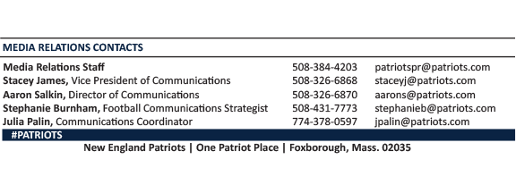
--PATRIOTS--

