PATRIOTS 2026 SIXTH ROUND DRAFT PICK DAMETRIOUS CROWNOVER
PRESS CONFERENCE
April 25, 2026

Q: Dametrious, welcome to New England, and congratulations. Where were you when you got the call, and tell us a little bit about your pre-draft connections with the Patriots, if there were any?

DC: Thank you. Yeah, I got to talk to Coach [Mike Vrabel] right before our pro day and came down and got to speak with Coach Doug [Marrone]. But, got to talk to him. Right now, I’m actually at one of my good friend Nate Jackson’s, his fiancé, their parents’ house. They opened up the place and let us – my whole family’s down there. They opened up the place and let us come and wait and watch.

Q: Hi Dametrious, congratulations. I’m just curious, how would you describe your game?

DC: I’m just dominant in the pass game, and just trying to make sure it’s something I hold to a higher standard. I’m still developing in the run game and making sure I’m getting better every time I step onto the field to practice it.

Q: Hey Dametrious, congratulations. Are there any NFL vets or pros that you look up to and model your game after?

DC: I watched a lot when I switched over to playing [offensive line]. When I first started playing O-line in college, everybody told me to watch Trent [Williams]. Trent’s the guy you’ve got to watch. I watched a lot of Trent. I watched a lot of LT’s [Laremy Tunsil] game from Washington, I believe is where he’s at. I watched a lot of their games and tried to take a little bit from each one of their games.

Q: Hey Dametrious, congratulations. I know you played mostly on the right side the last few years at Texas A&M. I’m curious your comfort level playing on the left side and playing some swing tackle?

DC: Yes, it’s definitely something that I’ve been working on, knowing that when I got to this next level that they’re going to ask me to do. So it’s something I’m not saying I’m 100% at. I would be so confident in my right side, but it’s something I’m still working on and getting there. But definitely something that I’m looking to do.

Q: Dametrious, congratulations man. Welcome to New England. Seems like you not only played multiple positions in football, but you played multiple sports. So, how has that background and having a little bit of experience in different things helped you play offensive tackle at a high level?

DC: Yeah, I played a lot of basketball growing up. It was my first love. I fell in love with it. I ended up going down this football road and falling in love with another game. But it helped tremendously, just keeping my feet underneath me and being able to move, my lateral side to side movements, stuff like that.

Q: Dametrious, do you have any connections currently in the Patriots locker room? Do you know anyone who’s played for the Patriots or currently plays for the team?

DC: I know Layden Robinson played for the Patriots; he is no longer with them. I don’t know anyone that’s currently playing for them, I don’t believe.

Q: Congratulations, welcome to New England. I’m curious, have you visited Massachusetts, New England before? Is there any memories that you may have of the Patriots organization growing up and how excited are you to get to that area?

DC: I’m extremely excited, I mean, for the opportunity they gave me. I can’t wait to be up there. I can’t say I’ve ever been up there, even, ever knew anything about Massachusetts. But I’m definitely excited to get up there and see what they have to offer.

Transcripts are provided by the Patriots media relations department as a courtesy to the media and are edited for readability. All press conferences are posted and archived in their entirety on patriots.com. The duplication or posting of this transcript in its entirety as original content is prohibited. Media are encouraged to link to the complete transcript on patriots.com when sharing full quotes with their audiences.

MEDIA RESOURCES
Schedule | Roster | Videos | Photos | Audio | Media Website | Twitter | Facebook | Instagram
Social: @Patriots | #PatriotsNation
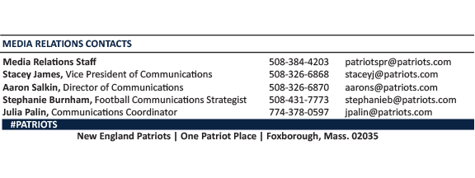
--PATRIOTS--

