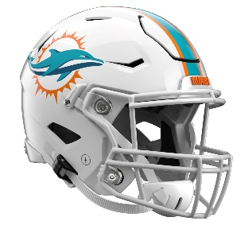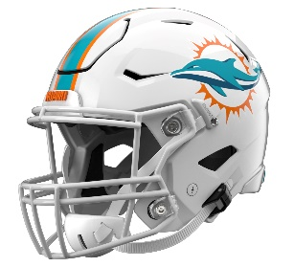

Miami Dolphins
Postgame Transcript
January 4, 2026

DOLPHINS QUARTERBACK QUINN EWERS
POSTGAME PRESS CONFERENCE
January 4, 2026

Q: First up, how you doing? Saw you were banged up there at the end. How are you feeling now?

QE: Still evaluating it. Don't have a whole lot of details right now, but we'll re-evaluate it when I get back. We'll see.

Q: What do you think, ultimately, was the downfall in this game? You kept the team in it for as long as possible, and then it got away from the team as a whole at the end.

QE: Totally, yeah. We started well, started playing well at the start. Then coming out, second half, I thought we put a solid drive together there. Then, I tried to go make a play there into the end zone, and unfortunately, I ended up throwing an interception, which is one of those things you wish you could have back. So, just more things to evaluate going into the offseason.

Q: What were you looking for on that throw into the end zone? Were you thinking about Tahj [Washington]? Because Tahj's man came off, or were you thinking that Theo [Wease Jr.] --

QE: Yeah, no, I was looking at Theo, and I think I was trying to force it a little bit too much there. I think I could have dumped it off to Greg [Dulcich] at the end of the day, but I think it's part of the learning process. I'm going to continue to try to grow as a player and also as a person, but like you said, Tahj's man just fell off, and I threw it right to him.

Q: What do you think improved over the three starts that you had?

QE: Yeah, I thought I did a good job of number one, responding to challenges all three weeks. It's unfortunate whenever the season doesn't end your way and how you want it to end, but I thought I did a good job of rallying the guys around me and continuing to fight.

Q: How do you think you should be viewed by the organization going into the offseason? As a guy who should have a shot at competing to start next season?

QE: Right. No, that's a great question. I'm behind this organization. It's the team that took a chance on me, and it goes all the way back to when I got drafted. They took a chance on me in the draft, and then they took a chance on me the last three weeks of the season, so I've got full trust in whatever decision they want to make.

Q: Quinn, according to this game today, early on, it looked everything was going well offensively. You were throwing the ball well, running the ball well. Second half, what changed at that point?

QE: I think it goes back to the interception I threw. We came out third quarter and I thought we responded really well after -- I forget whatever it was, but we had a pretty decent distance to get the first down on the first three plays. Then, we started the drive down the field, we got in a great position, and I think I just tried to force a throw at the end of the day, which kind of was the turning point in the game, which is unfortunate.

Q: So in the three games you played, do you feel confident that this league is not too big for you?

QE: At the end of the day, it all goes back, I think, to what I said last week and where my foundation lies. I think that helps me remain in each and every moment and not look too far forward, which only causes anxiety, and not look too far back, which also causes anxiety. So, when I stay in the moment and I encourage the guys, things seem to flow, for sure.

Q: You got to work with a lot of young pass catchers, experienced pass catchers through this course of three starts. What do you think about the potential of those guys, whether it's Theo, Tahj?

QE: I think that they're all solid players, and it was awesome to share the field with those guys because they came up big for me in big moments.

Q: Ultimately, what did it feel like playing in this environment, your first road NFL start, cold weather, just all of it?

QE: I felt great in it. I didn't feel like it was too cold out there to play football, but we're going to have to definitely take a look on responding in the second half of football games.

Q: What did you hear from Mike [McDaniel] at the end as this season now comes to an end just as we wrap things up here?

QE: Yeah, I think we were all frustrated, as we should be. It's the life of a competitor. When you're enamored with winning and winning, and it doesn't end up falling your way, you are frustrated, but I think that he was proud of the way that we continued to fight on these last three weeks after we kind of knew that we were eliminated -- three or four weeks, whatever it was. But I think he's proud of the way that we fought and responded through adversity.

Q: What do you think of this rookie class as a whole? A large class that came in, first year in the NFL. How do you think you guys gelled?

QE: I think it goes back to how we all responded. I thought we did a great job responding when our name was called and being focused on the opportunity that we all got. It even goes to the defensive guys that got opportunities that were rookies. I thought we all had a good showing of why they should have drafted us.

Q: How would you describe this last calendar year for you mentally as well as emotionally just with the ups and downs of what this last year has been for you?

QE: Yeah, that's a great question. Everyone says your rookie year is your longest year. It started back because I played -- January 10th was my last college football game. Then we jump into combine training, and so on and so forth. Now here we are, a full year later. Just a week less later, I guess. It's been long, but it's been what I've wanted. I wanted an opportunity to play in the NFL, got the opportunity when I was drafted, proved myself to where the coaches and the front office believed that I could start in the NFL and then won a game. It's a dream come true.

Transcripts are provided by the Patriots media relations department as a courtesy to the media and are edited for readability. All press conferences are posted and archived in their entirety on patriots.com. The duplication or posting of this transcript in its entirety as original content is prohibited. Media are encouraged to link to the complete transcript on patriots.com when sharing full quotes with their audiences.

MEDIA RESOURCES
Schedule | Roster | Videos | Photos | Audio | Media Website | Twitter | Facebook | Instagram
Social: @Patriots | #PatriotsNation
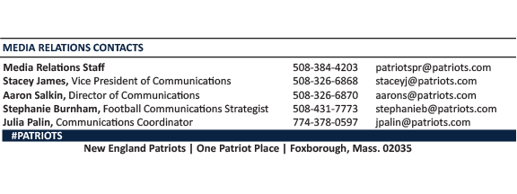
--PATRIOTS--

