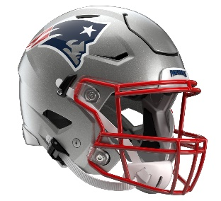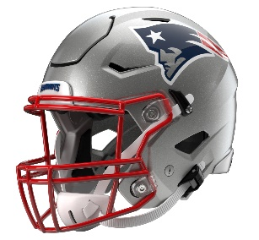

New England Patriots
Postgame Transcript
TBD, 2026

PATRIOTS QUARTERBACK DRAKE MAYE
POSTGAME PRESS CONFERENCE
January 4, 2026

Q: Drake, just a thought on what you guys were able to do. You were here last year; 14 wins, you make the playoffs, you'll host the Chargers here next weekend in a first-round match-up. How excited are you about what you guys were able to accomplish today and all season long?
DM: We've come a long way. It takes everybody. It took everybody in that locker room, took every coach. It starts now. This was one of the goals, host home playoff games, and this is what we wanted. It's win or go home, and the mentality, nothing changes from that standpoint, but really, we've just got to stay playing like us. We've built this identity and play to it, and I think good things happen.
Q: Drake, do you have any kind of relationship with Justin Herbert, and what do you like about him as a quarterback?
DM: I don't know if I've met Justin. I don't think I have. I know him through people and heard great things. Obviously, I love his game. I love the way he throws the football. He throws at a really high level. He can make plays on the move, can make plays off platform, he can launch it. I think just the way he holds himself and cares about his teammates, he's really about the team and not about himself. I have a lot of respect for Justin and how he plays the game, and he plays at a really high level.
Q: In a likely MVP season, I'm interested in what you feel like your greatest accomplishments were this year, whether it's from a statistical standpoint with the QB rating or whatever you were able to accomplish, what stands out to you that you're the most proud of in your accomplishments?
DM: 14 wins. That's the first thing that comes to mind. 14 wins and probably 8-0 on the road. That's probably the biggest thing I'm the most proud of is going on the road eight times and coming out victorious in all of them. So, that was pretty cool. From there, I think just the ability to get a lot of people involved. I think that's one of the best things about our offense. We get a lot of people involved. A lot of people catching passes, a lot of people scoring touchdowns, a lot of guys that are making plays at different parts in the game, and I think that's one of the toughest things about ways to defend us. So, that's probably what I'm most proud of.
Q: Drake, Christian [Gonzalez] just mentioned you guys might not even enjoy this one tonight because obviously, the playoffs are here next weekend. What was the messaging in the locker room as far as that goes, understanding it's a whole new season? Where is your mind at in that regard?
DM: Yeah, that's what Coach [Mike] Vrabel just hit on at the end. It's a new, different ballgame. It's win or go home, and that's what -- you lay it all out on the line. This is what you play in the NFL for. Playoff games, playoff games at home and a home crowd. We have an opponent coming in, and I know they've got some great players. Obviously, we saw them here last year. So, they're a good team.
Q: Drake, you guys are up 14-0, everything looked great, then it was 14-10 and things were stumbling a little bit. What made you guys able to find your rhythm again after that and score 24 straight points to end the game?
DM: Yeah, I think it's just staying true to us. Offense staying on track, getting ahead of the chains. I think the first three-and-out we had, it was three straight incompletions. I've got to find a way to get the ball in people's hands to make some plays and not have three incompletions. Then from there, we had a field goal that got blocked, and just wanted play true to us. It wasn't really something that they were doing. It was just us executing. They played a lot of zone tonight, so just executing versus zone, getting good spacing and finding ways to catch it and get up field. From there, our defense made some big plays. Coming out of the half, that interception was huge, and we just didn't stop from there.
Q: How would you describe Rhamondre Stevenson's impact of late and now the opportunity to use him in the passing game the way you have the last few weeks, complementing what TreVeyon [Henderson] is able to do?
DM: Yeah, he's a tough back. He can move. He's agile. He's got a little two-foot jump cut that I just love watching on film. He just makes people miss like that. He's got great hands. He's smart. His blocks in protection, unbelievable this year. He always tells me I owe him something. I really do; I do owe him something. He's done a great job. From there, we're trying to have backs that can do in in all three phases: running the football, catching the football and blocking. I think him and TreVeyon have done a great job of that. Obviously, we missed AG [Antonio Gibson], but AG is another one. So, having three backs that can do that, and Rhamondre is just -- you guys see him around here. He's as cool as can be and calm and chill, and he's a great player in this league.
Q: You mentioned the 14 wins being the accomplishment that you seized on the most. This team won four games last year. It won four the year before that. How did this happen? How did this transformation happen so quickly?
DM: Yeah, I think it starts from the top down. From the Krafts, them deciding to hire Coach Vrabel, bringing him in here and really just buying into what he was coaching us hard and coaching us to believe in. I think from there, it's us players. We got some new players in here, some new faces that have gelled together really well. We enjoy being around these guys. I know a lot of the defensive guys well and enjoy being around them. I don't think it's really any, 'Me, me, me.' I think the most 'Me, me, me' you saw this year was us getting some guys some incentives out there tonight. That was probably the most. That's just something that they've earned. I think from there, everybody pulls for each other. We're trying to get off the sideline to pump each other up, and it's always -- it's never a doubt in belief in what this team can do, and it works all three phases. We have a lot of belief in each other, and we hang out and enjoy being around each other.
Q: Speaking of incentives, Stefon Diggs hit an incentive for going over 1,000 receiving yards this season. I asked him about it, but I'm curious, for a guy who's coming back from an ACL injury to now have the season he's had, just what has his impact on this team meant to you, personally, and just what has he shown throughout this season to be able to reach this accomplishment?
DM: Yeah, first off, credit to Stef for his ability to bounce back and heal up from an injury like that in such a short period of time. Really since the first time I met him and I got the receivers together in the offseason, I invited him thinking, 'Okay, we'll see, who knows -- Stef is big time -- if he'll show up,' and he showed up and was running routes back home in North Carolina. From that point on, I felt like, 'Man, I'm looking forward to getting with him on the field and seeing him do his thing, and he's done his thing time and time again. Some games, he's not getting the ball as much as any receiver would want to, and he's still trying to block hard, keeping the energy up, breaking the team down and motivating me. He's meant the world to me, and I appreciate every time I go out there with him and a player like him. I just don't take that for granted. I'm looking forward to seeing him in playoff football.

Transcripts are provided by the Patriots media relations department as a courtesy to the media and are edited for readability. All press conferences are posted and archived in their entirety on patriots.com. The duplication or posting of this transcript in its entirety as original content is prohibited. Media are encouraged to link to the complete transcript on patriots.com when sharing full quotes with their audiences.

MEDIA RESOURCES
Schedule | Roster | Videos | Photos | Audio | Media Website | Twitter | Facebook | Instagram
Social: @Patriots | #PatriotsNation
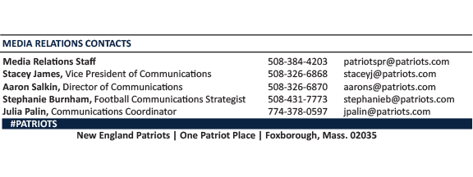
--PATRIOTS--

