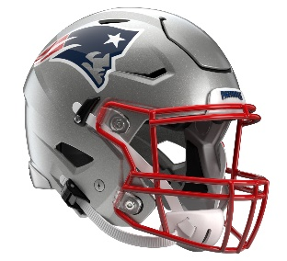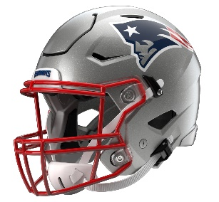

New England Patriots
Postgame Transcript
December 1, 2025

PATRIOTS QUARTERBACK DRAKE MAYE
POSTGAME PRESS CONFERENCE
December 1, 2025

Q: How much did you and the team just kind of feed off the energy? You guys came out with a lot of energy, too. Where did that come from? What was that like to watch all three phases kind of take it to them from the start?

DM: I think it starts with Coach [Vrabel] saying, "No naps." You want to come out here and start fast. We knew this team has been up in a lot of games, and they’ve got good players over there. They have some good talent. We wanted to try to get on them fast, and Marcus [Jones] helped us with that. What a return for him and the kickoff coverage. Just all phases of the game showed up at different points, and I still think, offensively, in the second half, we’ve got to put some more drives together to put the game out of reach.

Q: Coach Vrabel just said you're realizing what you can be and the impact that you make on the offense. What is that to you?

DM: Shoot, just trying to be the face, trying to be the conductor. He calls it the conductor of the offense. Trying to be the face of the offense, trying to want the pressure. You want the ball in my hands, and I’ve tried to show that all year and throughout my career. So, that's what I kind of feel like. I know they feed off of me, feed off of my energy and feed off of what I say to those guys. What I say means something to them. So, when adversity hits, I've got to respond. From there, I've just got to be the same guy, same guy every day. Don't try to change and just be myself. That's what the guys like the most.

Q: I was going to stay on Coach Vrabel. You hear those MVP chants a lot – whether you hear them or not, they're there. Do you think he's mounting maybe a campaign for coach of the year? He also promised to shave the mustache. Are you happy or sad about that?

DM: I thought it looked good. It was for a great cause. The award, I think he'd probably say the same thing. He’s worried about each and every week, and that stuff will come. But he's got my vote, and he's got a lot of people's vote. He's got everybody's vote in this organization, in that locker room and I'm sure across the league.

Q: Your coach referenced the hit the other quarterback got and playing through the whistle. He intimated that that might have been a subtle reminder to you on certain plays on being careful about being taken down hard. So, I guess, two quick questions. Did that resonate with you in any fashion, and was there any winking or eye contact from your coach after that play?

DM: No, I think it's something that's been across the league that has showed up with quarterbacks near the boundary or near the sideline just kind of relaxing. I think I learned last year with the Chargers, I had one on that same sideline over there. I got smacked on the sideline. So, just be smart and know you've almost got to accelerate, get down or do something over there. I think Jaxson [Dart], he makes some good plays with his feet, so he's tough to handle.

Q: Did coach look at you, give you one of these or anything like that?

DM: I don't think he needed to. You heard the hit from the sideline, so I think everybody in the stadium knew.

Q: Just as far as tonight, what went as planned and what might have surprised you, if anything?

DM: I think starting fast. I think starting fast when it's planned, that's what we wanted to do. I think we had some play designs that Coach had, and we practiced all week that worked. And I think that's the biggest thing, is that we knew they had a new coordinator calling it for the first time, so they're going to bring some stuff that we didn't expect. I think we tried to handle guys up front, had a great rush, great players up front. I thought the guys did that all night. The one sack we had was my fault. I think from there, Coach just saying ‘No naps’. I think we did a better job in the second half of living that and putting them out of reach and getting across midfield and putting the drive together to score a touchdown.

Q: Backups today at left tackle and left guard, what was the key for you guys on offense to kind of minimize that impact, I guess?

DM: I told them I had full faith in them. We had a lot of reps last year dropping back and trusting those guys. I think they're great players, and they've stepped up, like I said, in pregame. I think they stepped up all year anybody that’s been thrown in the fire. Proud of them. Proud of them for working hard and learning this offense and staying on the same page and being on the same page all night and doing a great job tonight.

Q: How cognizant were you guys of the bye and wanting to win going into the bye? And secondly, how much of a need is this team in need of this bye from both a physical and mental standpoint?

DM: I think wanting to win before the bye, you want to win every game. Kind of don't want to leave off on the bye on a bad foot with a home Monday night game. It was important for us to play on Monday night and show up for our fans, and it was a game that we didn't want to take lightly. I think the guys did that, proud of the guys for that. The bye week is huge. It felt like a long time coming, but we're here, and we have some important football after the bye week. We're looking forward to staying and getting healthy having guys that want to get better and looking forward to get some guys back and make a push when football starts to count down the road.

Q: Have you ever been on this kind of roll in either this sport or any sport, hoops, golf, anything?

DM: Golf, I like that. With my brothers this summer, I was on a roll a little bit, but I think back in high school, we won 13 straight, but no really, I think in college we may have won eight or nine straight, both in football. But this is a different beast. This is the NFL.

Q: You personally?

DM: Me personally? What do you mean by that?

Q: Your play.

DM: My play? Sorry, I don't know what you're asking.

Q: You kind of back boning 10 straight wins?

DM: Shoot, I wish it was all me. There's a lot of people in this locker room, this organization, that play a big role in us winning games. And shoot, just like you, showing up every day and making fun of you all for being in the locker room on a Friday asking us questions after practice, these guys are the same thing. They show up every day, and they want to get better. I’m just proud of the guys and this team we have and love being around them.

Q: They scored to make it a two-possession game. Was there any discussion going into your final drive just to ice the game?

DM: Yeah, it was big. It was big in the second half. We knew that they had a good offense and can move the ball. So, we had to put a drive together, put one down at the end to kick a field goal. Like I said, we won't be satisfied with that. Gotta try to punch it in, get the game really out of reach. But our defense is big, made big stops in the fourth quarter all year long. And just proud of these guys, like I said, and the good Lord has treated us right and we have to keep going. So, thank you, guys.

Transcripts are provided by the Patriots media relations department as a courtesy to the media and are edited for readability. All press conferences are posted and archived in their entirety on patriots.com. The duplication or posting of this transcript in its entirety as original content is prohibited. Media are encouraged to link to the complete transcript on patriots.com when sharing full quotes with their audiences.

MEDIA RESOURCES
Schedule | Roster | Videos | Photos | Audio | Media Website | Twitter | Facebook | Instagram
Social: @Patriots | #PatriotsNation
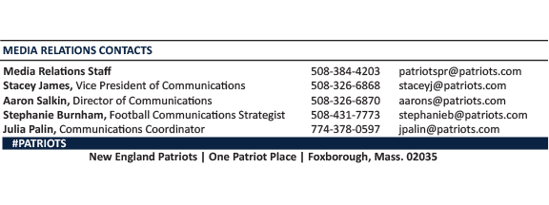
--PATRIOTS--

