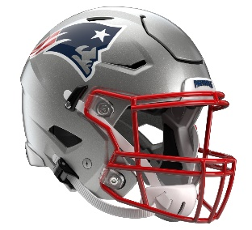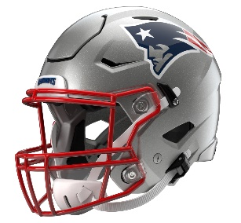

New England Patriots
Postgame Transcript
December 1, 2025

PATRIOTS HEAD COACH MIKE VRABEL
POSTGAME PRESS CONFERENCE
December 1, 2025

Q: Your thoughts on getting to this point, the energy that your team came out with, the hitting, and what they were able to accomplish, and now as you're headed to the bye?

MV: Well, I'm happy to be at the bye. Happy to be where we're at. Continue to improve. We have to finish better, but at least we came out ready to go. We focused on being aggressive, attacking and keeping that mindset, and I think we did.

Q: Just curious, with Vederian Lowe and Ben Brown sliding in, how did you feel they did tonight? You talked pregame about the Giants defensive front and how that was going to be a challenge. How those two handled it stepping in?

MV: I think they handled it well. I mean, we had some positive plays, obviously, offensively. We need to be better in the red zone, but I thought they did well, again, from first view. We'll have to see what things go on tomorrow.
There was a penalty that cost us a touchdown, so that's tough, but a lot of things to build on and continue to improve and really focus on things that we'll have to do a little bit better down the stretch here. But just proud of what the team has done week in and week out, whatever the challenge was and whatever has been presented to us.

Q: Pretty consistent and loud MVP chants for Drake [Maye] tonight. What impressed you most about his performance?

MV: I think he's able to keep his composure, keep his eyes down field. I thought some of the best plays, I think, are just the extensions, the scramble for a first down, the scramble and stay in bounds there late in the game, knowing the situation forces them to call a timeout. Then not throwing an incompletion there at the end of the game and scramble unselfishly. He probably could have said, ‘Hey, I'm going to try to throw a touchdown, just go and slide and use the clock.’ So, those are the things that probably don't show up on the stat sheet. I thought being accurate down field and being able to give Kayshon [Boutte] a real catchable ball there in the end zone was nice, too.

Q: Also, it's December 1st. How much longer are you going to keep the mustache?

MV: It will be gone tomorrow. I couldn't have done all this and not go out on Monday Night Football. It will be gone tomorrow. Probably before I talk to you.

Q: How would you describe just the message in terms of knowing the bye week was looming, knowing the Giants came in with two wins, and just making sure that your guys – you came out so fired up. What was that messaging in that way?

MV: I don't know how many wins they've had. I know that they get ahead, and they had Denver beat and had some other teams beat, put a bunch of points and yards up on Detroit, Chicago and all those other teams.
So, I think it was about just being aggressive, attacking and trying to keep a competitive stamina throughout the game and a demeanor no matter what happened. I liked the way we started and would like to have finished a little better, but we're doing a lot of good things to help us win, and I know there's some things we can do to continue to improve on.

Q: You've said, "being aggressive" and "attacking" a couple of times. Does the way – some of the way that Christian Elliss had some of those bigger hits at the beginning of the game, is that something that everybody feeds off of? Is that something that gives your guys a lift?

MV: I think our guys certainly did. I think our fans did. I think our team did. Again, it's a weekly reminder to the quarterback, our quarterback – we show them every week, I wouldn't get too cute over there by the sidelines. It happens every week. So, Christian's playing through the whistle, and as long as the player's inbounds, he's going to try to hit him legally. Then on the kickoff, we take a lot of pride in covering kicks. It was a matchup; they were top five. They were No. 5, and we were No. 6 in kickoff, and I expect us to be in the top five. That's what I try to tell our kickoff coverage team. So, it was good to see the impact it can make and turning the ball over as well.

Q: How important was it to keep momentum heading into the bye?

MV: I mean, I don't know if I looked at it like that, but I think we just focused on what the next task was, put a plan together, allow our players to feel confident in it, and then figure out what the bye week is and who needs to be here for treatment and who needs to get away. That's kind of really what we focus on. I don't think I was necessarily concerned with any sort of let-down because the bye was here. I think that there would be a lot of players and people that are ready for the bye and earned it, but I don't think that we were looking ahead to anything.

Q: Kind of similar, but 10 straight wins now. Week after week, you guys keep taking care of business and avoiding the slipup. What's been the key to not having one of those?

MV: Just things we talk about, doing our best to take care of the football and playing complementary. Today was obviously special teams that gave us a – Marcus [Jones] is just a fantastic returner, and I'm proud of the guys on that unit. They take a lot of pride in blocking for him. We took care of the guys on the edges, and those are tough. Those can be back-breaking for an opponent. So, we try to do everything we can to avoid them, and we try to create them. So, I think just the complementary phases, staying consistent in the message and players coming in here each and every week, practicing, preparing and obviously executing. Then when things don't go right, try to get them fixed and come back the next drive.

Q: Whether it's working around injuries, a short week, just using new personnel packages and play calls, the resourcefulness of your team, what has that meant to you in this season?

MV: Our staff, I'm always very thankful for the coaches that prepare our players; they've done a fantastic job. Josh [McDaniels], Zak [Kuhr] and the defensive staff, Jeremy with the special teams and helping spread the message that I try to have each and every week, but ultimately, it's on the players. It will always be about the players and trying to give them a plan that they believe in and that they can go out there and execute. Whether that's different guys at different places, I'm proud of them and I'm happy for them that they can have some success. I think people can see who we have, and the next guy steps up and can play and produce.

Q: What did you think of Drake's performance tonight? He seemed to be in control and didn't seem to be bothered by the issues with the offensive line with guys out?

MV: Yeah, I wouldn't say that was an issue. We just put the next two guys in there. Ben's been ready for his opportunity. Vederian has been working hard and worked hard in the offseason to come back from his shoulder. So again, to get those guys a full week of practice, I thought Drake is – I think he's realizing what he can be and the impact that he makes on this offense and being the conductor. He's hard on himself. I think that he challenges himself, as well as his coaches. He means a great deal to this football team, and just being able to not get rattled and escape, or pressure and find Rhamondre [Stevenson], or scramble. Then when we do have time and he sees a guy win, he put a ball in a great spot there for Kyle [Williams] to make a huge play or Kayshon down there in the red zone. A lot of third-down conversions. So again, very appreciative that he's our quarterback.

Q: Can you speak to the effort of the defensive line with so many guys missing or banged up, and also Elijah Ponder getting more opportunities inside as well.

MV: Cory Durden's been playing a lot for us, and we brought him over here from the Giants practice squad, or from the Giants. They let him go, and again, that game meant a lot to him. They told him he wasn't good enough to play for the Giants, and we thought that he was good enough to play for the Patriots. So, I'm happy for him. He made some plays and continues to help us, but also help himself, and I love that. You mentioned Ponder. Just trying to get some other guys in there rushing with some speed. Obviously, their quarterbacks can scramble and run, and we just felt like that was a package that we could try to use and get some other people out on the field.

Transcripts are provided by the Patriots media relations department as a courtesy to the media and are edited for readability. All press conferences are posted and archived in their entirety on patriots.com. The duplication or posting of this transcript in its entirety as original content is prohibited. Media are encouraged to link to the complete transcript on patriots.com when sharing full quotes with their audiences.

MEDIA RESOURCES
Schedule | Roster | Videos | Photos | Audio | Media Website | Twitter | Facebook | Instagram
Social: @Patriots | #PatriotsNation
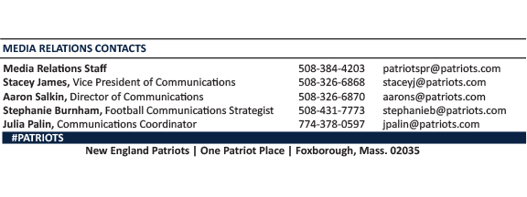
--PATRIOTS--

