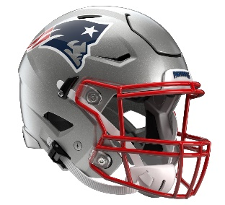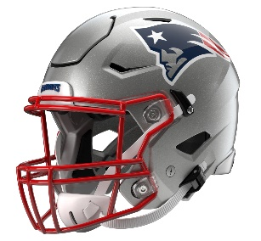

New England Patriots
Postgame Transcript
November 13, 2025

PATRIOTS QUARTERBACK DRAKE MAYE
POSTGAME PRESS CONFERENCE
November 13, 2025

Q: Just getting out of here with a win, the "MVP" chants for you tonight from the start, the crowd, just everything that went into this game and how guys were able to pull it out, too, with a lot of different contributions in a short week.

DM: Just a quick turnaround. The goal of these Thursday nights is to come out with a win, and that's what happened. Things we looked back on, didn't have as much time to prepare for, some things that I could look back at myself and wish I had plays back, but at the end of the day, just proud of these guys for the effort, the win, and that's the best thing about Thursday night. You get a weekend to catch up on some rest and some heal-up. I thought the fans were awesome. I think it was pretty sweet for the primetime game, here for my first play at home. Pretty sweet. Just glad we won.

Q: Drake, just curious, TreVeyon Henderson obviously into the end zone three times tonight. Just what you saw from him. You kept handing it to him. What was letting him have that success on the field?

DM: Don't fix it if it ain't broke. I think just him stepping up. It was a big time for him stepping up, and it's been great for him to get all these reps, to keep getting these reps. He wants to be great. He's just showing up every day and asking questions. For him to keep on going in the oncoming weeks and knowing that him, Mondre [Rhamondre Stevenson] and our backs, we can create a good one-two thing going. Looking forward to having Mondre back, but TreVeyon stepped up huge.

Q: Is the trust that you have in Stefon Diggs something that's built up over time, or do you feel like you had that right away?

DM: No, that trust was built up probably when I was in middle school when he was playing in the league. It was long ago. Guys like him, Hunter [Henry] and Mack [Hollins], you trust those guys for what they've done in this league. I just try to give them chances. Stef, he had to break a couple of tackles to get in the end zone, but those guys were great for us tonight.

Q: Drake, asking Hunter about you, and he said, ‘Short memory. If a play doesn't go the way he wants or series, he forgets it quickly.’ How important is that to you, and is that something you had for a long time?

DM: Yeah, that's huge. That's what we're trying to build. Having short memories in this league as a quarterback, that's what it is. You're going to get sacked. You're going to have plays that you want back, and just trying to flip the page and just knowing that there's so many sports out there. Basketball, I was at the Celtics game the other day. You see somebody miss a shot, and they just run back, come back here and shoot another one. That's just kind of the mindset. Shooters shoot, and that's what my mentality is. Me and Hunter play a lot of ping pong, so it's just the next point and just keep going. I think that's just my mindset.

Q: Drake, has anything surprised about your personal success, this team's success during this run, surprised you that you didn't know about yourself? And also, as you start to near the playoffs here, what are the top things that you are looking on improving?

DM: No, I don't think anything has surprised me. When you put the work in and we’ve got good players and good coaches, you are going to get a result that you want. Obviously, there's been some results this season, some losses, and you build from that, learn from it and try to learn about it every week. I think we're going to enjoy the weekend and get ready for next one on Sunday. I think it's Cincy. Is it Cincy? Yeah. So, just trying to take it one week at a time.

Q: I know quarterbacks will talk a lot about accuracy versus ball placement, certain shoulder or lead guys to get them to go back. Is there anything that you do in regard to ball placement to focus or work on that, specifically?

DM: In zone, you always drive to the catch, try to see where defenders are at. I’ve got the best view of throwing to him. So, try to put it on the right shoulder. There were times tonight where I felt like I did that, and there’s some times where it needs to be better. I hit Stef on a third down coming into the fourth quarter, that was big. I thought it was good ball placement. There's guys across the league that are so great at it, so just trying to practice it in practice and know that every throw and mechanics and just rip it.

Q: How does it feel to get those "MVP" chants and just have people recognize the way you're playing right now?

DM: Yeah, may have been for TreVeyon tonight. He scored three touchdowns. No, I think our fans have been great with me since I got here, since I got drafted. I just appreciate them for embracing me. Just trying to embrace this city and give these fans, this team and just myself, just leave it all out there and give it everything I’ve got.

Q: It seemed like the Jets had kind of a similar approach to what Tampa did where it's fewer blitzes than they're used to. I know they played a little more man. Did you see it the same way, and did it help to have the short week to get right back out there and keep going?

DM: You know on a short week they're probably going to do some stuff that either we haven't seen or you think it's what you have seen, but oftentimes you see something that didn’t show up. They play some dime on third down and got a few different looks where we got emptied a lot. They showed some different looks that emptied, but I thought they did a good job defensively of disguising. Coach [Steve] Wilks, I think he's from Charlotte. Shoutout to him. They blitz a lot, and we didn't see as much tonight, but you can see they’ve got a lot of different stuff. They’ve got good players. I thought the backers were great, and the guys up front on the edge are good players. So, they're a good football team, and I think we'll have a tough challenge when we see them again.

Transcripts are provided by the Patriots media relations department as a courtesy to the media and are edited for readability. All press conferences are posted and archived in their entirety on patriots.com. The duplication or posting of this transcript in its entirety as original content is prohibited. Media are encouraged to link to the complete transcript on patriots.com when sharing full quotes with their audiences.

MEDIA RESOURCES
Schedule | Roster | Videos | Photos | Audio | Media Website | Twitter | Facebook | Instagram
Social: @Patriots | #PatriotsNation
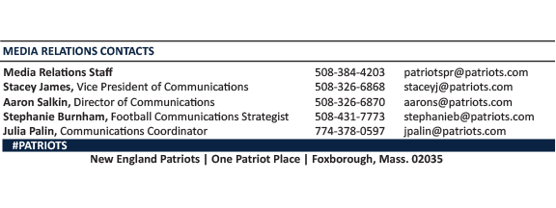
--PATRIOTS--

