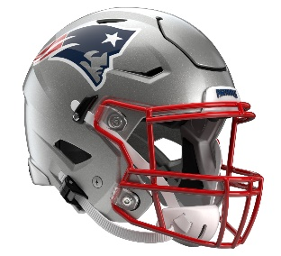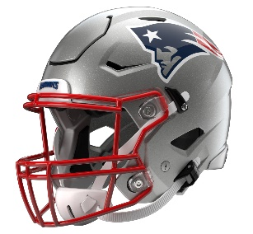

New England Patriots
Postgame Transcript
November 2, 2025

PATRIOTS QUARTERBACK DRAKE MAYE
POSTGAME PRESS CONFERENCE
November 2, 2025

DM: First off, Salute to Service week. We met some families yesterday that came to practice that had a fallen soldier, and on the back of my helmet, we had “JC” for mine. We honored different players throughout the game. It was Jack Casey. He was a Marines captain, and he passed away last year. So, it was cool to honor that. This week in the NFL, it’s cool to honor those who serve in our country. It's pretty sweet how they put their lives on the line, man. They're the true heroes, and it's bigger than football. So, just want to say that. We got the win today; that was pretty cool to get the win during that week.

Q: Just to follow that up, how important to get out of there with a win with a couple of turnovers that you had, but also the 17-yard play on third-and-5 at the 23 to complete to [Hunter] Henry? How good was that for you guys as a group to finish it off?

DM: Yeah, first, I've just got to play better. I’ve got to play better for this team down the road. It's tough, it's tough in a game where you win and you can feel in that locker room that these guys know we can play better. I think it's a good feeling to have, but also at the same time it's tough to win in this league, so you've got to enjoy it. You've got to enjoy it. Hunt made a big play down on the sideline, five-minute. Shoot, we didn't want to make the defense make another stop for us again. There are so many things to learn from this game, and I'm just proud of this team for – it doesn't matter if it's 24-23 or 3-2. So, I’m proud we got the win.

Q: I know you said it's not your best game clearly, but one thing in the second half we all noticed, after the interception and you were on the sideline, it looked like Mike Vrabel came right up to you, had some encouraging words for you. How important is that for you as a young player, and if you might share a little bit about what he said?

DM: Yeah. He's great at coming up to me after really every drive. He comes over and says something to me, always positive, always wanting me to rally the guys around me, always challenging me to battle adversity and get the guys going. I just appreciate the way he coaches me. He's hard on me, but he's very positive, and he wants the best out of me. Everything that he says to me, I think it's gone to be important and become true.

Q: You said you've got to play better. What about your game did you not like today that you want to –

DM: 21-7, we really got a chance to get some more points going into halftime. Free rusher, the first thing I’ve got to do, I told our quarterbacks coach, just got to tuck the ball to the chest. Getting into a bad habit of trying to break tackles on these guys that I don't have a great chance of breaking a tackle on. Then, ball on the 50, around midfield, and I'm not sure of the score. I think we were up – yeah, 24-14. I wasn’t on the same page with Hunt, gave the ball back to them at midfield, and now it just changed the game. So, really the turnovers, and other than that, just trying to stay more positive. We were good on first and second down, and I think we were good on third down today, but just try to stay in third-and-manageable and just keep making plays and battling from adversity. That’s what this league is.

Q: You had that run in the first half, I think, where you got hit pretty hard and pretty high. Was that just you, ‘Dammit, I'm just going to go full speed ahead,’ or you just didn't have room to slide? Can you take me through that?

DM: Yeah, I tried to cut back. Like I said, cutting back is probably not in my repertoire. I need to get down. Pop [DeMario Douglas] cut back and made it look a lot better than me on the long catch. So yeah, just get down. I just revert back to my natural instincts in the open field, but yeah, I need to get down.

Q: You guys had a lot of success hitting them with those crossing routes throughout the entire game. What did you guys see during the week that led you to believe against that secondary that you could hit those big plays down the field on those crossers?

DM: Yeah, I think they played some match coverage. They were challenging us to beat some man routes, beat some man coverage. I missed some more crossing routes that I wish I could have had back. Credit to our guys; we challenged them all week in the receiver room and tight end room to win against match and be physical at the top of the route, and those guys made some big plays today.

Q: Outside of the turnover, what did the Falcons do to give you guys trouble in the second half?

DM: Yeah, first half I thought we were rolling. That first drive out of halftime, I thought was big. They held us in the red zone, but it was a big drive. I think we took up almost nine minutes or eight minutes. The second half, I think it's just stuff that we can control. Once we handle adversity or once we face adversity on the sideline, I think we can do a better job of handling it and moving on. Like I said, our defense stepped up big for us, and that last five-minute was cool to – with the ups and downs of the game, to finish on that.

Q: Mike talked about some of the joy and appreciation that comes along with winning in this league. Do you feel that right now, or is there kind of a frustration about the miscues? How do you come out of this one mentally?

DM: Yeah, shoot, so far in my career, I think just trying to enjoy these wins. It's tough to win in this league, and from my short career in this league, I think you've just got to enjoy it when you get in the win column, enjoy getting another chance next week to face a good team on the road. I think just enjoy the wins and know deep down I'm frustrated and I want some plays back, but that's a good defense we faced, and those guys in that locker room are cool to be around and play with.

Transcripts are provided by the Patriots media relations department as a courtesy to the media and are edited for readability. All press conferences are posted and archived in their entirety on patriots.com. The duplication or posting of this transcript in its entirety as original content is prohibited. Media are encouraged to link to the complete transcript on patriots.com when sharing full quotes with their audiences.

MEDIA RESOURCES
Schedule | Roster | Videos | Photos | Audio | Media Website | Twitter | Facebook | Instagram
Social: @Patriots | #PatriotsNation
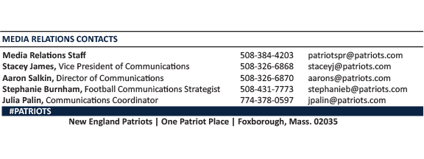
--PATRIOTS--

