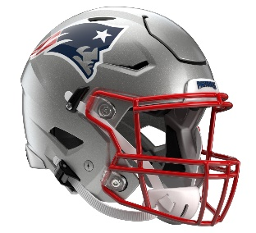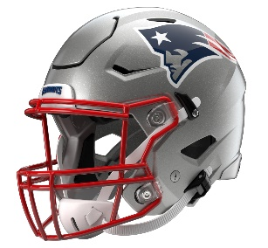

New England Patriots
Postgame Transcript
November 2, 2025

The following FastScripts transcript is provided by ASAP Sports. Please note that for speed and efficiency, this transcript has only been lightly edited and the final edited version of this transcript will be circulated at the end of the night.

PATRIOTS HEAD COACH MIKE VRABEL
POSTGAME PRESS CONFERENCE
November 2, 2025

Q: It's six straight, but I'm guessing there's some things you'd like to clean up.

MV: Sure, but it's a funny league, and we're going to learn from winning so that we don't have to learn from losing about taking care of the ball and complementary football and how quickly things can change. End of the half, we take a nap, like we talked about the other day. We took a little nap and they scored and made it a one-possession game. Give them a lot of credit, but give our guys credit there for finishing and coming up big when we had to in the fourth quarter with the pressure, the intentional grounding forced them to punt, and then offensively being able to finish with the football was huge. Great timing by Drake. Great catch by Hunter, getting a couple extra yards and staying inbounds, all the stuff that we practice in five-minute, and they're believing in it and they're buying into it because they see that that's what good teams do to end the game.

Q: Mike, just to follow up on that, with all that happened in the game for you guys with some adversity, how good is that for them to see that, go out and execute it, and then say, hey, we do all this, but we can do this when we needed to, made the stops, made the plays, and get out of here with a win?

MV: They're talented. They're a good team, and that's what happens when you do, and you keep teams around when you keep them in the game. Give them credit, but also give our guys credit for battling back when we had to. It wasn't great there. We had our spurts. We had our moments. But when you're cleaning up, need to take care of the football and be better defensively in the red zone. That's been our issue, and they made some good plays down there, but we've got to be better in the red zone.

Q: You've talked a lot about the unselfish nature of your receiver group. What can you say about Pop Douglas who made the most of his opportunities today?

MV: We've got to keep finding Pop. You always look, and when Pop doesn't have the ball and somebody else does, he's turning and blocking and doing all the things that we ask him to do to protect our identity. We have to continue to find him on some of these runaways or some of these slot plays that are really good for him. I love having him on the team. He's fun to coach. He sits right up front, and he's always into it. Great teammate. Always happy for his success.

Q: I know in New Orleans your message to the team was you've got to enjoy winning. What was the message knowing you guys won despite not playing your best?

MV: Just get ready to go on the road. Understand that that's how it goes in this league sometimes. It's tough. But embrace -- don't let anybody take the joy of what we do. Joy is authentic. Joy comes from these guys caring about each other, being happy for the guy next to them that made a play. Joy is about what we do in here, and I think that they need to embrace that and be thankful for what they get to do and what I get to do. We talked about when you get -- sometimes you get this taken away from you, whether you're a player and you get cut or you're a coach and you get fired and you get another opportunity, you want to try to make the most of it and enjoy it.

Q: We saw you talking to Drake on the sideline after that interception. It looked like some encouraging words. How important is it for you to pick him up in that spot?

MV: Well, I just have to play a lot of different personalities and try to figure out what's best for our football team. I told our offense that we were going to need one drive to win the football game. At some point in time, I think there were seven minutes left, I said I don't know if it's going to be a two-minute drive or it's going to be a five-minute drive, but we're going to need one more drive from you, and that's all that's going to matter. As soon as the defense goes out there, I'll let you know if it's going to be a two-minute or a five-minute, and it ended up being a five-minute. They executed.

Q: When you blow somebody out, everybody can see that big win, everybody is excited about it, but when you win a game like this, how big of a win is it for this group moving forward to win a close game like this?

MV: Well, we've won some close games, and I think that we did kind of learn a little bit about ourselves. You can make mistakes, and you have to be able to come back and finish the game. There's a lot of snaps still left, and understand what is needed from us. It's a fun group to coach because I think that they're going to always want more. They are receptive to the coaching. They give us everything they've got. We're nine games in. We practice hard, and we play, beat up, we're going on the road. I'm glad and appreciative of everything that they've given us thus far halfway through the season.

Q: Just wanted to ask about the cornerback room and how they did today, specifically with it seemed like you had Marcus and Carlton all over the place and also with Christian going out and Charles going in?

MV: Yeah, everybody has got to be ready to go. Sometimes we challenged, and they made a play. Drake London is a good player. I'll be able to evaluate the performance more tomorrow when I talk to you, but Charles Woods is ready to go in there and play and be ready for his opportunity. It's kind of what you have to do. You have to be ready to go and step up, so we made some plays and they made a few, but ultimately we made more than they did.

Q: In the last drive when you threw it and had a few yards to go and the clock was stopped and Atlanta had the last time-out, how much conversation was there between you and Josh between running the ball, let the clock go, or put it in Drake's hands and let him make a play?

MV: It was pretty quick, just go win the game. Go get the first and win it. That was a quick conversation.

Q: Drake's strip sack, Will Campbell ran all the way to make the tackle. What does it say about him as a player and the offense as a unit?

MV: Well, I think that those plays, if you do those enough, you're going to save points. There's going to be another time in the season where somebody is going to have to do that and the defense is going to get a stop.
We weren't able to get a stop on that particular effort, but that won't go unnoticed. I appreciate your perspective and your willingness to point that out because the play is never over. Maybe the next time that ball gets knocked out, Will knocks that ball out or Diggs is chasing a receiver one time and knocks the ball out or chasing the linebacker down in Cleveland. So we don't want to turn the football over, but when we do, we expect the effort, and that's certainly the -- Will was doing that, and that's going to save points the next time.

Q: It seemed like you guys had a lot of success running inside today. What did you see from TreVeyon Henderson and Terrell Jennings having to step up obviously with Rhamondre out?

MV: Yeah, they ran hard. We had some openings I wish we would have been able to pop a few more. But we moved them and we get on the second level and felt like it was okay. Could have been better. Really just -- we get disjointed a few times. Too many seconds and longs, too many times we put ourselves in long yardage, but we converted. We were good on 3rd down, even with that. So again, the run game, and those guys will complement each other. Backs ran hard and took care of the ball, and then we had a few perimeter plays. We'll just try to figure out what gives us the best chance each and every week to win the game.

Q: You had Terrell Jennings with the ball in his hands on that last drive, you had a touchdown earlier. What has he done to kind of earn the trust that you gave him in those big spots?

MV: I mean, he's run hard. He's run hard in five-minute. He's a physical back. Those guys rotated most of the game. And TreVeyon helped us win and so did Terrell, trying to get the ball to everybody in the rotation. Just in that situation, I think, where Josh was going to go with some inside runs there at the end, just get a little bigger back in there. Excited to keep moving forward with these guys and get Rhamondre back as soon as he can get back.

Transcripts are provided by the Patriots media relations department as a courtesy to the media and are edited for readability. All press conferences are posted and archived in their entirety on patriots.com. The duplication or posting of this transcript in its entirety as original content is prohibited. Media are encouraged to link to the complete transcript on patriots.com when sharing full quotes with their audiences.

MEDIA RESOURCES
Schedule | Roster | Videos | Photos | Audio | Media Website | Twitter | Facebook | Instagram
Social: @Patriots | #PatriotsNation
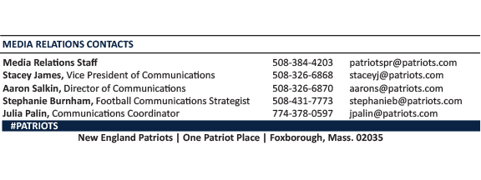
--PATRIOTS--

