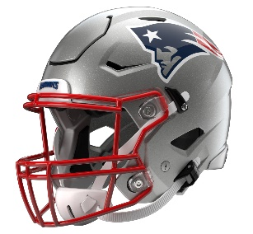

New England Patriots
Postgame Transcript
September 28, 2025

PATRIOTS HEAD COACH MIKE VRABEL
POSTGAME PRESS CONFERENCE
September 28, 2025

Q: ...To say that Marcus Jones kind of lit the fuse today for you guys?

MV: I think that's what we've been looking for. I talked about that throughout training camp and how those return units need to be a weapon for us. We've got the one kickoff return, but to be able to do that on the punt return, fantastic effort by Marcus and everybody else out there. I think a lot of that was just his own individual will, skill and effort. Again, that has to be a weapon. It was something that we felt like could be through this season and getting ready for this year.

Q: What is it about Marcus that makes his skill set so superior?

MV: He's not the biggest player, but he's got great play strength, I think, with the football in his hand. He's got great vision, and, again, you have to be fearless at some level to catch that punt and know that you're going to make the first guy miss. We're confident in that. I think he kind of just - it's just a natural skill. That's hard to teach. It's hard to teach with all those bodies in traffic, catching it first and making great decisions with it back there. It's a lot of comfort with him back there, and we need to continue to make it a weapon.

Q: Coming off of last week's loss, how much did you need a performance like today? And how good does it feel to be able to put together a performance like this?

MV: You always need it. You only have so many opportunities. Whatever you do in one week, it doesn't really matter. It's about what you do the next week moving forward. Hopefully we take that same approach whether we win or we lose. I think that's what I've tried to do is, whether you win or you lose, we've got to embrace moving on. We have to do that. We have to prepare here for a division opponent on the road. It's going to be a great environment, and hopefully we'll see where we're at.

Q: Talking about the defense, obviously you give up that opening score, but then you guys bounce back and pretty much shut them down the rest of the game. Talk about the adjustments you guys made and how you were able to take control of the game on that side of the ball.

MV: Just settled down a little bit. They did a nice job early on moving guys around. We have to continue to disguise better, tackle better and all those things. If that's the tradeoff for playing great defense the rest of the way, then we'll have to go through those growing pains early in the game. I don't anticipate that we should, but it was good to see us respond, and we've done that. I'm proud of our guys for not going in the tank or complaining or pointing a finger or anything like that.

Q: What did you see from Drake [Maye] today and the way you guys were able to spread the ball around on the offense?

MV: Just throw to the guy that's open in the progression as soon as he's open. If not, quickly progress through. Those are the things that quarterbacks have to do. They have to have a command of it, and we did that. I think the read zone clearly is a big factor. Our ability to convert those chances into touchdowns was important. I saw a lot of extra effort, guys blocking downfield, springing guys. Again, I like when everybody's involved and the quarterback just throws to the guy that's open every play no matter who it is.

Q: I saw you with the "T Strong" shirt. A lot of the players were wearing them as well. What does it mean to get a "W" when he's [Terrell Williams] going through something pretty serious here?

MV: I don't think that those things are really comparable. We've got one situation where somebody is fighting and we're playing a game. We care deeply about Terrell, and we're going to do everything that we can to help him, to support him and make sure that he gets what he needs, competes, fights and that we take care of him as people and support. That's the big thing there. The other side of it is, it's just the game. We understand how critical the wins and losses are, and we're here to win. But I don't look at it like, "Oh, we have to win because this is is Crucial Catch." We just have to win so that we can continue to build a program that can stand, that can withstand everything that goes on in this league.

Q: When you mentioned moving on in reference to Buffalo next week, you said, 'Hopefully we'll see where we're at." What did that tell you about where the team is right now?

MV: That when we don't beat ourselves, we take care of the football, we play complementary football, we get stops on third down, the return, the special teams are a factor and we score touchdowns in the red zone, it can look like something. Again, that's not guaranteed every week, but certainly we can see the difference in how critical those phases are and putting them all together.

Q: Marcus Jones has played some offense here at points before. Given how dynamic he's been with the football in his hands, is that a possibility that you'd ever consider using again?

MV: We'd consider anything that would help us win or score points, certainly.

Q: Have you considered it?

MV: We consider everything. Again, we've got a lot of guys that are producing over there. We'll see where that goes and how it translates.

Q: It looked like you had some starting defensive linemen on the field on Marcus' first return score. I was wondering, were you anticipating a fake on that play, and what was it that maybe led to that decision?

MV: We like that gray team. That gray team can be just as good. Whether you're trying to think it's a fake or you like those guys pushing in there, you've got two choices in punt return. You can either hold them up, or you can knock them so far back that it takes them a little while to get down there and cover, and there's some displacement in the lanes. We'll continue to mix those up and try to use everybody where we see fit in how they can help us. Whether it's trying to go rush a punt with some bigger guys or try to manufacture a return.

Q: Big game, obviously, from Stefon Diggs. Was that an emphasis this week, a matchup you guys saw, or just where the ball was going?

MV: No, just where the ball is going. Stef [Stefon Diggs] and everyone has done a nice job. If we can continue to believe in the quarterback, that he's going to throw to the guy who's open in the progression, then good things will happen. We get down there in the red zone, and everybody's going to score. We've got plenty of plays down there. If everybody just stays the course, does the right things and does all the things that helps the team, that those plays are going to come for them in the red zone. It's just like the defensive line. They want sacks, and they want all this. [Christian] Barmore is disrupting the quarterback, and he's getting holding calls. I don't want him to be frustrated, but I see those things. Pop [DeMario] Douglas would have liked to have a couple extra catches today, but he also turned and blocked, and Hunter Henry ran down the sidelines. Nobody's going to say it unless I say it. And so, those are the things that matter, not the guy catching the touchdown. That's the easy part. The hard part's the guy that didn't get the ball thrown to him that turns immediately, blocks his guy and we score from the 25-yard line.

Transcripts are provided by the Patriots media relations department as a courtesy to the media and are edited for readability. All press conferences are posted and archived in their entirety on patriots.com. The duplication or posting of this transcript in its entirety as original content is prohibited. Media are encouraged to link to the complete transcript on patriots.com when sharing full quotes with their audiences.

MEDIA RESOURCES
Schedule | Roster | Videos | Photos | Audio | Media Website | Twitter | Facebook | Instagram
Social: @Patriots | #PatriotsNation
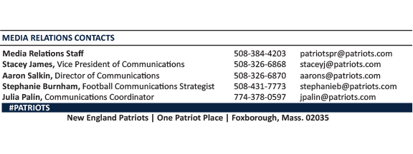
--PATRIOTS--

