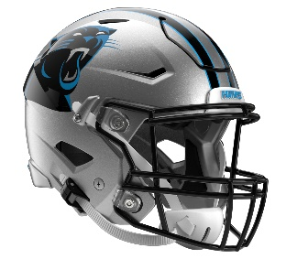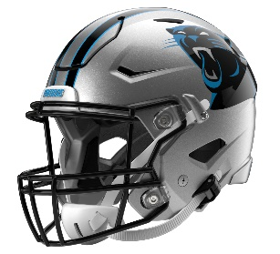

Carolina Panthers
Postgame Transcript
September 28, 2025

PANTHERS HEAD COACH DAVE CANALES
POSTGAME PRESS CONFERENCE
September 28, 2025

DC: Certainly not the execution we're looking for. This is in all phases, first and foremost, giving the credit to the Patriots. They outplayed us in every phase, offensively, defensively, on special teams, with the big return yardage on that. When it's a full team effort like this, I have to put that on myself. I have to look at how I'm preparing the team, how we're going about our work. I have to look at that and compete to find an edge to get these guys to work together, to focus so we can get the execution that we're seeing happen in our processes. But this is the only way to work through these things, is to go right back to work, to attack it head on, and with the guys, I told them in the locker room, "Hey, a loss is a loss; we've got to look at this stuff, we've got to look in the mirror and figure out who we want to be as a team so we can get the execution that we're calling for and that we're looking for."

Q: It feels like you put a lot of emphasis on the way that this team finishes games. What was the challenge in coming in with a strong finish today?

DC: I can honestly say that the effort and the energy from our guys is there. It keeps coming back to the execution. I have to look at that myself. Are we putting our guys in the best situation to be successful in every phase? I have to make sure that we have those conversations and that we keep progressing our football forward. I know who our guys are. I know they're not going to quit. I know they're going to continue to punch, they're going to continue to fight all the way through it. But it's not enough. We have to be able to come out and execute for four quarters to become the football team that I believe we can become, and the work starts right now. It starts with me. It starts with our coaching staff. The players understand as well, this is not acceptable, and this is something that we have to come together and make sure that we're together on this thing so we're pushing forward.

Q: You were OK with the effort on the first defensive series when they went down the field? There was a play when (inaudible) kind of swiped at the ball when he could have shoved [Hunter] Henry out of bounds.

DC: I loved the effort. I loved the way the guys were flying around, and we have to find the balance of being overly aggressive in certain situations and just making sure we're in good position, good leverage to make the play. Again, I have to be able to evaluate that and make sure that we understand that.

Q: (Inaudible)... I think this is the first I've heard you say that this loss is on you. What stood out to make it on you moreso than any other game?

DC: Well, just the collective execution. When it happens in all phases, I'm the common denominator, and I have to take responsibility for that. I have to make sure I'm pushing the guys the right way. I have to evaluate what we're doing, how we're working, how we're preparing our guys. I felt confident about that part, but we're not getting the results. And so, this is something that I have to just really press in, making sure we're not overlooking anything and making sure we're having the right combination of guys out there in every phase.

Q: Special teams had a really good week against Atlanta, and then this week there's struggles. How do you absorb such a difference in performance on special teams?

DC: I've got to look at the film first to really see where the breakdowns were. We knew they had gifted returners. We were aware of that, and it just felt like we weren't getting quite there on our coverage. I have to be able to see the film to see exactly why that was and how that played out. But I know we had a couple of shots at the guy, he made a couple people miss and then the rest of their blockers were in phase. That's a part that we're going to have to look at and evaluate.

Q: You referenced this, but it seemed like y'all were slow in coverage. Did that show up (inaudible)...

DC: I've got to look at the film, honestly, to give you a true assessment of what that was like, whether it's a combination of the rush and the coverage, were we in the right position? I'll be able to tell you more about that once I get to see the film.

Q: Will Bryce [Young] be your starter next week?

DC: Absolutely. Counting on him to keep pushing us forward, counting on him to keep us on track. There were some near misses across the board, some penalties that put us in weird situations, a couple of protection issues, and one of them where he slipped and kind of put us in a bad situation. But I still feel that he's being confident out there. He's leading the group. He's getting us out there with good energy and focus. And so, he'll continue to play.

Q: You went to the tight ends a lot today. Was that just kind of what you had in the receiving corps or something you saw from the Patriots?

DC: Well, I like our 12-personnel attack, but when D-Mo [David Moore] goes down early, then Dalevon Campbell is out and all of a sudden you're playing with three receivers. I felt like we needed to be a little bit more 12-personnel, 13-personnel heavy to finish out the game, and that's really what amounted there. I like our different 11-personnel packages, but we've got to be smart about making sure our guys were out there with the right energy.

Q: It's got to be kind of a shocking defeat I would think. The margin and, as you said, across the board (inaudible)...

DC: Absolutely, and that's where I start with myself because, again, I'm the common denominator when all phases aren't executing the way that I expect us to execute. I have to look into our processes and I've got to make sure that we're pushing, we're competing every single day the right way so that our guys are in position to be successful.

Q: What about David Moore? Do you have an update on him?

DC: We're going to be looking at it week-to-week. It was an elbow injury that happened on the first play, which was a really nice run by him. A guy that we're counting on, so we'll be week to week with D-Mo.

Q: Bryce and T-Mac [Tetairoa McMillan] really seemed to have chemistry all season. What's happened to that? Today it seemed to be pretty way off there.

DC: I agree. It was some near misses there. That's something we've got to look at on film and just make sure that they're on the same page.

Q: You talked about the common denominator. Would you consider giving up play calling?

DC: Not right now. I believe that I'm the right person to be able to push our concepts and our schemes forward. I think it's a combination of a bunch of things. Execution-wise, am I calling the right plays rhythmically for the guys to have success based on what the defense is doing to us on that day? That's something that I'll definitely look at, though.

Q: You've been through different combinations of linemen, [Brandon] Walton first, then Brady [Christensen]. What went into that?

DC: Yeah, we had a heavy package planned for Brady and then also for Brandon. The other part is Brady is our backup center, so we went with Brandon first to just make sure that Brady was available in case anything else happened at the center position. But we wanted to make sure we came out of this game with Brady having a chance to be out there and play, just kind of looking into the future and the next couple of weeks to see if that's a place where we're going to really need him. And so, we kind of went with that approach after Brandon had that first series.

Q: Last week you're 30-0, feeling good. How do you explain these two extremes where it looked so good and then today looked so bad?

DC: Yeah, I wish I could tell you. That's going to be a lot of film study, just looking at the players, looking at how we're executing our plan with our base calls and some of the things on both sides, really. Again, to me, this game is about consistency. Can we consistently play good football? And today was not that. Today the Patriots played excellent football in all three phases, beat us that way. And that's when you get that type of margin of victory, is when you're firing on all cylinders in all phases. That's something that we have to look at and make sure we're taking the right steps forward.

Q: Do you think you're going to be making any changes in your coaching staff?

DC: Not right now, no, but we're going to look at all the stuff tomorrow, put our heads together and make sure we're pushing forward the right way.

Transcripts are provided by the Patriots media relations department as a courtesy to the media and are edited for readability. All press conferences are posted and archived in their entirety on patriots.com. The duplication or posting of this transcript in its entirety as original content is prohibited. Media are encouraged to link to the complete transcript on patriots.com when sharing full quotes with their audiences.

MEDIA RESOURCES
Schedule | Roster | Videos | Photos | Audio | Media Website | Twitter | Facebook | Instagram
Social: @Patriots | #PatriotsNation
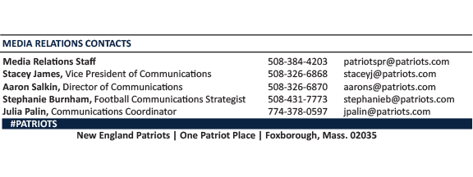
--PATRIOTS--

