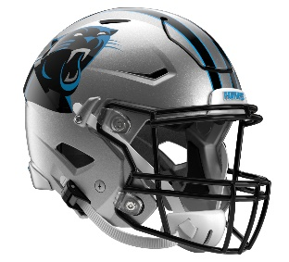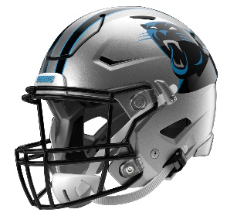

Carolina Panthers
Postgame Transcript
September 28, 2025

PANTHERS QUARTERBACK BRYCE YOUNG
POSTGAME PRESS CONFERENCE
September 28, 2025

BY: It's on me. It's on everybody in that locker room. We talked about that after. We all take accountability. We all have to look in the mirror. We all have to understand what we can do better. It's definitely not on one person. It's all of us that have to be better.

Q: You and T-Mac (Tetairoa McMillan) had a really good chemistry for preseason, first games, but today you seemed off by a little bit. What do you believe caused that?

BY: Missed some stuff. I take accountability for that. It's on me. Missing my opportunities. We'll watch film, and I'll be better and we'll all be better.

Q: How do you keep the guys (indiscernible)?

BY: We just have that next-week mentality. It's not fun right now, of course, but we have another one next week, which is a blessing. We have to learn from the tape, own it, wear it, but after 24 hours, we wash it and make sure that next week we can be the best version of ourselves.

Q: Bryce, what was working on the first drive that ultimately didn't work thereafter?

BY: We were just executing. Wasn't anything magical happening. We were executing. Obviously we have to be able to sustain that moving forward.

Q: You said there was nothing magical about it, but you started (indiscernible) is it purely just executing? Is there anything else?

BY: There's execution; that's all it is.

Q: Do you think people were trying too hard to execute?

BY: No. It's just we have to execute. We all take ownership of that. We all take ownership. Good or bad, we have to play the next play. We have to do a better job of that next week.

Q: David Moore's injury, I know it was the very first play of the game, but how did that impact things thereafter?

BY: Obviously we all feel for D-Mo. Obviously what he brings on the field, in the locker room, everything else. He's such a great energy. Just having that veteran presence and just that joy about ball that he brings every week, obviously when you see that, that's rough. Unfortunately that's the sad part of the nature of the game. There's no excuses for anything. Things happen, unfortunately. We have to make sure that we execute. There's no excuse not to do that. So, we have to be better.

Q: When you're building a team, you've got to build depth, and you've lost a lot of key players. Was that showing up today do you think?

BY: Again, that's part of the game. Unfortunately, roster things happen. We feel for everyone who things happen to. That's the NFL. It's part of it. We have to make sure it's on us to execute.

Transcripts are provided by the Patriots media relations department as a courtesy to the media and are edited for readability. All press conferences are posted and archived in their entirety on patriots.com. The duplication or posting of this transcript in its entirety as original content is prohibited. Media are encouraged to link to the complete transcript on patriots.com when sharing full quotes with their audiences.

MEDIA RESOURCES
Schedule | Roster | Videos | Photos | Audio | Media Website | Twitter | Facebook | Instagram
Social: @Patriots | #PatriotsNation
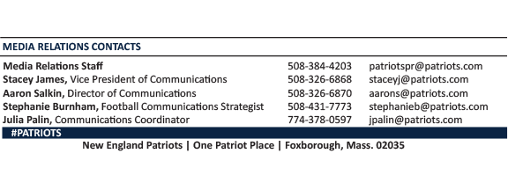
--PATRIOTS--

