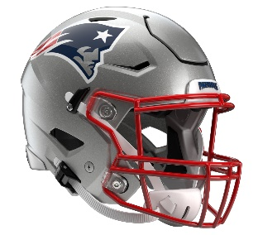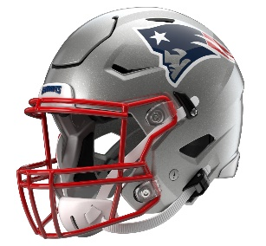

New England Patriots
Postgame Transcript
September 28, 2025

PATRIOTS QUARTERBACK DRAKE MAYE
POSTGAME PRESS CONFERENCE
September 28, 2025

Q: After last week and the week maybe talk about protecting the football, how pleased were you with the way things unfolded with your group today?

DM: Just proud of the guys. I thought they played hard. We get back to our fundamentals and kind of back to establishing our identity. I felt like we did that. Probably didn't hurt ourselves. A few penalties we'd like to have back and obviously three-and-outs we could have done a better job on first down. Proud of the defense. They put us in some great spots. Marcus Jones, can't say enough about him. Shoot, he's the best in the game at it. I feel it was a full team effort and proud of the guys.

Q: Drake, there was a play in the third quarter where it looked sort of similar to Pittsburgh last week. You had pressure. You went up in the pocket. You were surrounded by defenders. You protected the ball and just sort of went down. Then three plays later you threw the touchdown pass to Hunter [Henry]. How good is it to see some positive reinforcement that sometimes the best play is just live to play another play?

DM: Yeah, probably throw it away too. Don't take a hit and don't give those guys up front a one-yard sack. They hate me for that, and I apologize to them. Other than that, yeah, if there's nothing there, just try to live for the next play, live another day. Just learn that, and I think it leads to good things.

Q: Talk about the offense. You guys got into a rhythm early, and you were able to sustain that throughout the game. What were your overall thoughts on the offense today?

DM: Just proud of them. Proud of them for - kind of what we put on tape last week was not what we want to do and who we want to be. I thought those guys, we established the run early, we had some different scheme kind of plays that kind of gave the defense some misdirection that I thought we hit right on the head and turned into explosive plays. Just proud of the guys. Just kept on fighting. I thought we were good in situational. I should have hit booty on the first third down and missed behind him, so could have been even better. There's still stuff to work on. Proud of those guys, and it starts with the guys up front and just keep going.

Q: Is this kind of the best version of yourself, like kind of taking what the defense gives you, moving the ball around, managing the football some is this how you project who you want to be moving forward?

DM: Yeah, I sure hope so. If it leads to wins, that's what I'm trying to become and the quarterback I'm trying to become. I try to do it kind of just my whole career, kind of spread it around and give it to the guys that can make plays. I think everybody's got some chance on our team, our skill guys, to make the defense - give them a problem. I think we've got guys on the team that are great with the football in their hands and I just try do my best job to get to them quick and don't hold it.

Q: You lit up when you were talking about Marcus there briefly. What does that play, the first one in particular, do for the team? It seemed like, I don't know, maybe you were in a little bit of a rut early on and then boom.

DM: Yeah, it's nice. Golly, it's fun seeing that. You kind of always know, I think when he's back there, you've got a chance to get a great return. I think the best thing about it, it makes you feel comfortable when he's back there of making a great decision, whether it's touchback or whatever he's doing. I sure hope they keep kicking it to him because he's fun to watch.

Q: You looked real comfortable out there. How big of a role did your offensive line play in that? What did you think of those guys today?

DM: They played the role. They start every play. I think those five guys are playing their tails off, playing their butts off in the run game, in the passing game, learning the protection system, learning third down, different looks. Garrett [Bradbury]’s communicating with me basically on the front getting into different plays. Can't be more proud of those guys up front and they continue to do it each and every week.

Q: You had told us during the week that you wanted to get going with Stef [Stefon Diggs] and find him. How good was it to kind of see him get behind the defense on a couple of days and for you to find him?

DM: He looked a little faster than I thought. He looked pretty fast. I think he's just going to keep getting more comfortable. Shoot, he's a great player with the ball in his hands. He's a great leader on this team. He's great with the energy, being positive, and glad he's a Patriot.

Q: It looked like you guys had some successful shotgun runs. I'm curious, what about those looks specifically gives you guys an advantage versus when you're going under center?

DM: We always try to hunt up 6 boxes - a 6 box with a tight end, try to make it 6-on-6. That's football. Try to block the seventh guy and the eighth with our receivers, that's football. If it's sitting in the gun or under center, just try to get a hat on a hat. Our backs are good players. Give them some space, and they'll make somebody miss.

Q: On your rushing score, you hit the Cam Newton Celly, the Superman. I just wanted to know, how much has Cam, when you were a young kid, just influenced how you play the game and how you wanted to play quarterback, maybe emulate his style?

DM: I think it was cool seeing those jerseys. Right when I saw those jerseys, it reminded me of Cam, just the energy he brought. I don't show much emotion out there, probably need to show more. Times when I do, yeah - it's a fun loving position. I think he played the position in a different way than a lot of people do, and the guys around him rallied around him. I had another one late, I think in the third or fourth, I had a safety one-on-one. I know Cam probably would have took him on and tried to score. Yeah, I got to meet him through the process. I'm a big fan. He was my favorite player growing up, so pretty cool.

Q: You had at least seven X plays here today. What about your preparation in the film gave you guys confidence you'd be able to hit some today, and what did you see?

DM: We knew their corners were good players. They've got a good cornerback duo, and they try to match for outs, so just try to get our guys running away from them and give them some misdirection looks on different run game stuff. I thought our guys executed well and kept on moving and kept going. I felt like it was good not to have 15- to 17-play drives. It felt good to kind of get some lower play drives and end up in the end zone.

Q: How much more comfortable are you feeling right now compared to Week 1?

DM: It's each and every week in this offense. I think there's still stuff on the tape that Coach will get on me on, and I think that's the best thing to do is with a loss, you kind of learn from it and take it to heart. Also, when you win, look at the tape and learn from it. There's things that are going to show up in this game that matter down the road. Yeah, getting more and more comfortable. I think those guys around me are helping me out. Thank you guys.

Transcripts are provided by the Patriots media relations department as a courtesy to the media and are edited for readability. All press conferences are posted and archived in their entirety on patriots.com. The duplication or posting of this transcript in its entirety as original content is prohibited. Media are encouraged to link to the complete transcript on patriots.com when sharing full quotes with their audiences.

MEDIA RESOURCES
Schedule | Roster | Videos | Photos | Audio | Media Website | Twitter | Facebook | Instagram
Social: @Patriots | #PatriotsNation
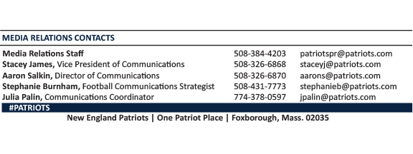
--PATRIOTS--

