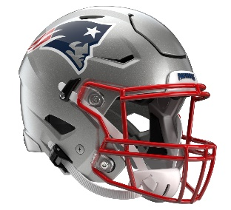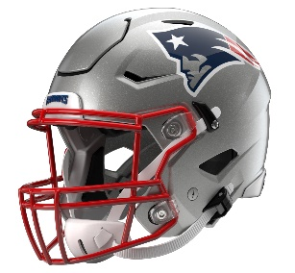

New England Patriots
Postgame Transcript
September 7, 2025

PATRIOTS HEAD COACH MIKE VRABEL
POSTGAME PRESS CONFERENCE
September 7, 2025

Q: You spoke to us about winning the second half, and that didn't quite happen.
MV: No, it sure didn't. Again, it's frustrating. We have to understand how sometimes these games are going to go. We just didn't do enough in the second half. Give them credit. We certainly didn't do enough. We had too many missed opportunities, too many penalties, the turnover, and things that just — didn't take advantage of bad football and then were able to have bad football ourselves. We're never going to accept winning. We have to embrace moving on, and we have to do that quickly and get these things fixed and go on the road and a division opponent.
Q: How surprised were you by that second half, and what do you learn from it that you can take into next week?
MV: I'm not surprised. I'm not surprised by anything. I'm surprised that — now we'll see where we're at. We'll see what kind of football team we have, what kind of leaders we have, to be able to come back in here and get to work. I think that'll be the true test. We always talk about culture and everything else. We'll see where we're at as a culture and as a team and if we have guys that want to work and stick together. It'll be a big challenge to do that.
Q: How would you assess Will Campbell's performance in his NFL debut?
MV: I think that's tough right now. I apologize, I've got to look at the tape. Again, I'm sure there's going to be some good plays, some plays we'd like to have back, that he would like to have back. I think that would go for pretty much everybody. I think there was some good football, just certainly not consistent enough in all three phases. That's kind of what it looked like for me, and I'll try to give you a little better answer after looking at the tape.
Q: I know it's hard to match with them given [Ashton] Jeanty and [Brock] Bowers, but they seemed to be running pretty well when you guys went three-corner and then obviously throw on you a little bit late when you went base. Can you just talk about the thought process…?
MV: Well, just trying to make something — we didn't think that the run game had hurt us, and they picked us a couple times, and they hit a couple long ones, and they hit some X plays, which we talked about that being a key. We'll get back together. I thought we settled down really well defensively. I thought the first drive was not our best, and then I thought we settled down. I thought they played well, and I thought they played hard. We just weren't able to make enough there in the end. Again, I made a decision on 4th-and-10 with close to five minutes to punt and would like a better punt, and we had them stopped, and that was the plan, and that didn't work. Then they hit one, and we just didn't have enough time there at the end to do anything. That was the decision that I thought was best for us at the time, and that didn't work out. But situationally we'll have to continue to improve. We moved the ball. We made the kick. We tried the onside. You just can't get down two scores late in the game.
Q: After Andy [Borregales]'s kick in the first half, the team went nearly two quarters without getting on the scoreboard again. Did the Raiders do anything different on defense? What did you see?
MV: They mixed in some pressure and a little bit of mixed coverage. But again, give them credit. We'll have to come back and we'll have to be better and more balanced and be able to run the football without making it 1st-and-20. We overcame some of those, but it was just too difficult. Again, it's a start. Not the one that we wanted. We've got a long way to go, and we're going to be resolved to get it fixed, and the people that are here are going to be committed to getting it fixed together.
Q: You mentioned the X plays by the Raiders offense. I was wondering what from your perspective led to some of those things and some things you can improve moving forward?
MV: Well, just understanding the coverage, understanding eyes, and I think it all goes into sometimes the call. They had a good call for what we had on, or a guy made a play. When you look at X plays in general, offensively you scheme them up about 35 percent of the time, and about 65 percent of the time, somebody makes a play. So, I would say that the same would go defensively. Sometimes we're not in the best call and they scheme us up, and then other times somebody makes a play, and just like we were able to get our hand on a football, they go 13 personnel, and we were pretty adamant that they were going to throw, and they tried to hit 89 (Brock Bowers), we tipped it and we made a play. But we just have to have more of those, and we have to create some more turnovers.
Q: How would you assess Drake [Maye]'s performance? Looked like there were some struggles under pressure in this game.
MV: Again, without looking at the tape, I thought there were some good positive plays and really good command of what we were doing, and then there were times where maybe we or he missed somebody, and we'll have to see. It's a challenge playing quarterback in this league. We've got to help him out. We have to be more balanced. We have to use our run actions and be able to run the football. It's hard to turn it into a drop-back passing game in this league. That's just the facts. When they're up two scores and they're in their 3rd down package, we just don't want to ever live in that world. We all can be better, whether that's me, the coaching staff, Drake, Will [Campbell] and everybody that you asked about, that's the attitude that we're going to take. That's the belief that we're going to take. We're disappointed, but we can't sit there and hold on to it too long. We've got to go on the road and we've got to play a division opponent, and we've got to embrace moving on. I think that's what we're going to try to do.

Transcripts are provided by the Patriots media relations department as a courtesy to the media and are edited for readability. All press conferences are posted and archived in their entirety on patriots.com. The duplication or posting of this transcript in its entirety as original content is prohibited. Media are encouraged to link to the complete transcript on patriots.com when sharing full quotes with their audiences.

MEDIA RESOURCES
Schedule | Roster | Videos | Photos | Audio | Media Website | Twitter | Facebook | Instagram
Social: @Patriots | #PatriotsNation
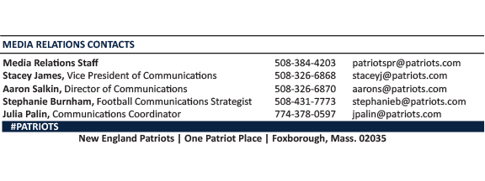
--PATRIOTS--

