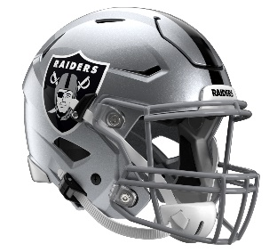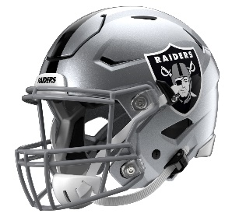

Las Vegas Raiders
Postgame Transcript
September 7, 2025

RAIDERS HEAD COACH PETE CARROLL
POSTGAME PRESS CONFERENCE
September 7, 2025

PC: Good win. Really important first day for us to get off and come from behind and win the game in the second half and believe the whole way through that we were going to find a way. Defense did a tremendous job in the second half to hold them down, getting off the field in the third downs and all of that, just playing tough as heck. And really excited for our guys. We've worked really hard to get to this point, and to get in that locker room and have that kind of fun and cheer on one another and all that. But it's East Coast, I don't know, East Coast, we don't mind coming out here. Maybe we can keep that going.

Q: You've seen Geno Smith do this quite a few times before, but today talk about the statement game from him. In terms of what he can do and stabilizing --

PC: Yeah. For him to complete over 70 percent of his passes again, I mean he's been doing this. Geno had a regular game today. I don't think it was a big statement game or anything like that. I just think it's just what he does. And we'll do better than that. We got rushed a little bit today a couple of times, and that really kind of changed his opportunities to have even a bigger day. But the fact that we had so many big plays - somebody said we had nine plays over 20, like tied the record or something like that. I can't believe that now. I can't believe with all the guys we've had in the years here at the Raiders we'd have more than that. But it was still a big day for us and he did a great job.

Q: Toward the end of the first half, offense kind of hit a lull there, seemed like coming down to the third quarter, Geno particularly still maintained that level of confidence. What goes into that for a player being able to have some moments and then shake it off and get back to it?

PC: He's a star player in the NFL. He's been doing this for a long time. That was a normal response by him to just not worry about it. We took a couple of sacks on pressures that we didn't need to take. I wish we'd have gotten rid of the football instead of getting hit. But other than that - and there was a couple of penalties in there, it felt like that made a difference and we were second-and-20 or something like that, or first-and-20. Really hard to play from there. But other than that, shoot, I thought we were fine. I wish we'd have run the ball better. They did a nice job up front against us. We didn't get much going. But we stayed with it enough to give us the play passes that we needed to throw the football around. Jakobi [Meyers] had a different game running after the catch and getting pounded and then making more yards. I thought that was special. Tre's touchdown was perfect with the protection they picked it up versus a pressure, and we hit a touchdown pass. So a lot of good things happened across the board, and we're really happy about it.

Q: You guys lost Elandon Roberts, but it seemed like with the linebackers, the communication stayed true and they stayed with it even with that loss?

PC: Yeah. He sprained his elbow, and we'll see what that all means. He's tough as nails, and if he can come back, he will. Yeah, but those guys have been rolling a lot. John Glenn has been moving those guys through so that we have fresh callers and guys that can communicate really well. So it wasn't that far off for us to deal with that properly. Tommy [Eichenberg] got a little playing time in there, which was great. But I thought the whole group played really well.

Q: What's your level of concern with Brock Bowers injury?

PC: They're looking at his knee. He wanted to go back in and they wouldn't let him go back in. They thought, let's watch the game, see how it goes; we didn't have to do that. But he's an incredible player. So, yeah, we need to have him.

Q: How did you game plan for Drake Maye and how well do you think you guys stuck to that game plan?

PC: Well, this first game you really don't know what you're getting. We saw them in preseason, and they saw us in preseason. We didn't motion one snap in preseason this year. We were moving a lot today, if you noticed. They, likewise, they did things that they hadn't done. So in this first game and even the second game and the third game, these are all games that are a little bit loose on what you're planning for because teams can change and they haven't really showed their hands. Some of the clubs that have been together for a long time is a little bit different. But the new teams, brand new team, we didn't know what they were going to do and Josh [McDaniels] had a lot of good calls in there, a lot off good stuff that he did against us.

Q: Pete, you mentioned that the run game wasn't quite there, but you did have success with the play action passing game. What did you think about the run game?

PC: Well, they still got under the run. They were getting fired up and hyped up about stopping it. I thought Chip [Kelly] called a great game to take advantage of that. Their aggressive style at the line of scrimmage allowed us to get a few plays out of them and that's just kind of how we play. Hopefully we can keep that going. But we'll need the running game a lot more formidable than that.

Q: You preached compete since you got here, and today towards the end of the first half when the team got behind, you could tell they were frustrated, but they never quit competing. Is that why you do it from day one? You install it. You just can't turn it on game day?

PC: Yeah. That is the essence of why it's the central theme in the program is, so that you never call it at any one point. You just keep competing and you just keep battling, play after play after play. We don't pass judgment. We just keep rolling. And these guys were talking like that at halftime. They were talking like it on the sidelines, and they kept talking about just keep doing the right thing, keep doing the right, and we'll work our way out of it. That is the conversation that we're trying to develop on a regular basis so there ain't nothing that we can't handle. So, it was a good illustration of that. Thanks for pointing that out.

Q: The 20-yard play was on third and 20 in the fourth quarter. Can you talk about that?

PC: That was a huge play. That really swung the game where we really were in command of the game from that point on. That was a huge job by the guys up front, because Geno [Smith] had some extra time there, and he got a chance to throw it down there on a really nice, unusual play that Dont'e [Thornton Jr.] makes the catch on. It was a very significant play in that game, and fortunately worked out. We still could have won the game without that one, but that play really kind of put us on top of the game for us.

Q: Also Michael Mayer, talking about at No. 2 tight end, I guess.

PC: He ain't number two tight end. We got ones. Those guys can all play and do stuff. Mike made some big catches today and held onto the ball great. Unfortunately, we had one fricking ball tipped today and they get a pick on it. But we played with the ball in our hands really securely all day long, which is what we've been doing everything in our power to own once we get to these games. I was really proud of that today.

Q: What do you think of your young corners? I mean, they just stepped up today.

PC: I thought they did fine. Really we had two PIs called on us. I think you could go to both of them, and you could see the offensive guy ran into Eric [Stokes], I think it was, and knocked him back, and the guy, the side judge couldn't see it really. But I thought that was one that didn't have to get called. And I thought Kyu Blu [Kelly] did a nice job fighting to the hands without making something that impeded that receiver. So I challenged both of them, and I thought those guys played really well.

Transcripts are provided by the Patriots media relations department as a courtesy to the media and are edited for readability. All press conferences are posted and archived in their entirety on patriots.com. The duplication or posting of this transcript in its entirety as original content is prohibited. Media are encouraged to link to the complete transcript on patriots.com when sharing full quotes with their audiences.

MEDIA RESOURCES
Schedule | Roster | Videos | Photos | Audio | Media Website | Twitter | Facebook | Instagram
Social: @Patriots | #PatriotsNation
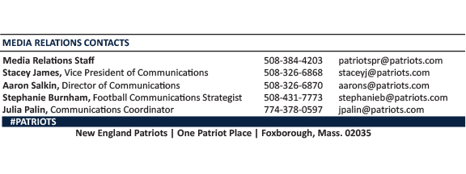
--PATRIOTS--

