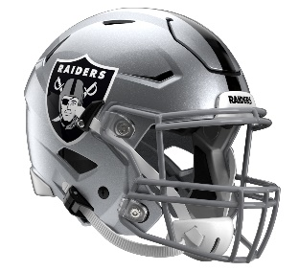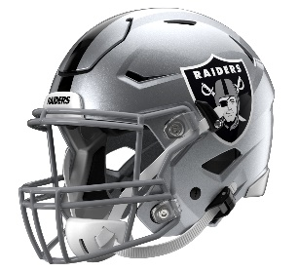

Las Vegas Raiders
Postgame Transcript
September 7, 2025

RAIDERS QUARTERBACK GENO SMITH
POSTGAME PRESS CONFERENCE
September 7, 2025

Q: Congratulations on your first win as a Raider, Geno. You know Pete [Carroll]'s system. You know his 'Compete, compete, compete,' but at the end of the first half when they were ahead and things were not going well, your teammates -- there was nobody hanging their heads. You could see it. They were just hanging in there. How proud are you of your teammates that they bought in to Pete's 'Compete, compete, compete, compete?'

GS: Yeah. I'm extremely proud of the guys. First of all, it's always a blessing to get a win in the NFL. The Patriots, they have a good team. It's the NFL. There's going to be ups and downs, ebbs and flows throughout the game, but I think the message that Coach sends us is that you’ve got to stay even keel, and you’ve got to never pass judgment. You’ve got a four-quarter game you’ve got to go play. So, I thought we did a really good job of coming back into the locker room, regrouping and then executing in the second half.

Q: You've been involved in these East Coast games, and his [Pete Carroll's] record is ridiculously good. Why do you think that is?

GS: I think Coach has a really great way of going about it. The two-day trips, just all the things that we do, it really works, and you can see it. Obviously, the guys have got to go out there and execute and it's got to be right, but Coach has a style about him. He has a way about him. He understands exactly what he wants, and the message is clear. So, when we get out here, we know what we're doing. Business trip. We take a two-day trip, study, study, study and then get out on the field and get it done.

Q: Geno, it's third-and-20 late in the fourth quarter and you find Dont'e [Thornton Jr.] on that first down throw. What's going through your mind on that play? Was that the play that was called or did it --

GS: Obviously, in those situations, man, game on the line, I love the ball in my hands. That's what I live for, man. That's what I play this game for. We were running a lot of plays, a lot of in-cuts, and I felt like we could have taken advantage of some things earlier, but I feel like that was the perfect timing for it. So, Dont'e made a great play, ran a great route. The protection held up. They were in Cover 0. So, we got a chance to take a shot on an aggressive corner, and it worked out for us. Those are the things we can count on from Dont'e and from our O-line.

Q: Geno, for you personally, as an individual, when you have something like that interception early in the game, what goes into maintaining that confidence and sort of moving on to the next play?

GS: I think I say it all the time: I'm me. That's all I think about. I don't think about anything else. I'm me. I know who I am. I know what I can do. Mistakes happen. Things happen within the game. It was a tipped pass. I made the right read. I could have made a better throw, but those guys made a play on it. The ball tipped up; the guy made a play. I'm not going to hang my head; I'm going to keep going. I'm me. Coach tells the story about Rick Barry, and one day I'll get to that with you guys, but I just know who I am. I know what I can do on that field, so I never worry.

Q: They were really aggressive and sending pressure, blitzing often, but you had a few moments out there where they were getting after you and you still were able to make plays. I think about the fourth-and-1 pass where you were on the move and hit Michael Mayer. What goes into sort of being aware of your surroundings in those moments?

GS: Just anticipating the aggressiveness, knowing the situations. Most coordinators are going to be aggressive in those situations. They’ve got to get the ball back, got to find a way to get a stop. So typically, they're going to be aggressive. They have to. So, when you're out there, you're playing, you’ve got to make a play. Those are when I think the best players show up is when you’ve got to make the play. Everyone knows the situation. There's no secrets, you’ve just got to go out there and make it happen.

Q: You've been around Brock Bowers now at least since March or so when you got here. It looks like you guys have been playing for five years out there today. What kind of an asset is Brock Bowers?

GS: Man, Brock is a tremendous asset. He gives us the advantage in personnel because he's such a tremendous player all around. So, D-coordinators, they've got to figure out how they want to guard him, and we've got to adjust to it. Brock's a great player, but I think all our guys showed up. I thought Jakobi [Meyers] had a great game today. I though Tre [Tucker] had a great game. You see the big plays that Dont'e made. Tough running by Ashton [Jeanty]. It's hard to do that in a four-minute situation when the whole stadium knows we're running the ball. Our O-line played well. I thought they gave me a ton of time back there to get through my reads. Chip [Kelly] called a great game. I think it's a collection of all of us having to do those things, but having Brock obviously makes my job a lot easier.

Q: Earlier in the game, you had already targeted six of your teammates and obviously it was even more than that by the end of the game. In Chip's system, how much does it help that if you're on the roster, you're part of the offensive game plan so they have to watch everybody?

GS: Oh, yeah. I mean, that's how we want to play football. We want to make sure that we make the right reads. I want to make sure that I'm making the right decisions and getting the ball into the hands of the play makers. We got a lot of great players, and that's something we can take advantage of. So, I'm going to spread the ball around if need be, but I'm going to find the open guy first and foremost.

Transcripts are provided by the Patriots media relations department as a courtesy to the media and are edited for readability. All press conferences are posted and archived in their entirety on patriots.com. The duplication or posting of this transcript in its entirety as original content is prohibited. Media are encouraged to link to the complete transcript on patriots.com when sharing full quotes with their audiences.

MEDIA RESOURCES
Schedule | Roster | Videos | Photos | Audio | Media Website | Twitter | Facebook | Instagram
Social: @Patriots | #PatriotsNation
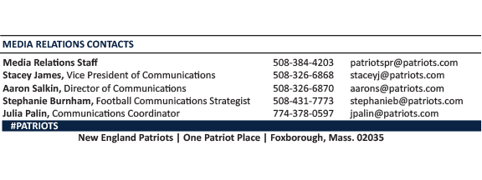
--PATRIOTS--

