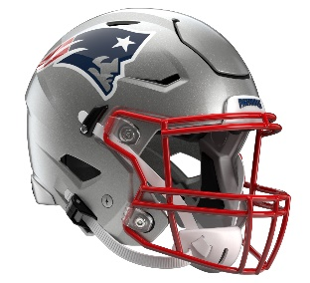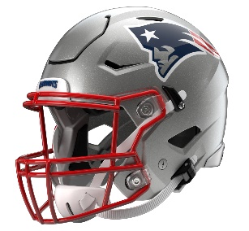

New England Patriots
Postgame Transcript
September 7, 2025

PATRIOTS QUARTERBACK DRAKE MAYE
POSTGAME PRESS CONFERENCE
September 7, 2025

Q: Drake, obviously you won the first half; Mike [Vrabel] has been preaching to win the second half. What happened from your perspective where you weren't able to generate points with the offense, especially in the second half?
DM: Yeah, we've just got to be better. I think my decision on the first drive coming out was the one that killed the drive, and from then on, we've just got to get the first first down. Once we got the first first down, we moved the ball well and got in a rhythm, and I think it's an adjustment from halftime. I've got to do a better job of getting the guys and making throws. I thought the guys up front battled hard. They blocked them pretty well up front, I thought, and like I said, just get the first first down, and from there just make some better throws, be more accurate. I think getting points out of that first drive would have been huge.
Q: Could you take us through the play that led to the interception?
DM: I thought I had [Stefon] Diggs. We were on the right, and I've got to look back on it on film. You don't have a great look at it. I think I missed it high. I think I've got to step into it more. I may have got hit up front, but that's just part of playing quarterback in this league. You've got to step into the throw, take hits and be accurate. There's plays throughout the game you wish you had back, and I can think of three or four for me that can help dictate the game. It's a bummer thinking back and looking back at those.
Q: Drake, can you tell me what happened in the first half on the delay of game? It was third-and-12 at the Vegas 17. You guys broke the huddle with about 14 seconds. What happened there? It looked like maybe you were trying to change the play.
DM: Yeah, just trying to get into a good play. I think I've just got to be better with bringing the back back in the backfield, timing it up with the play clock. I saw it at the end, and I think I surprised Garrett [Bradbury] trying to get the ball. I think that's what happened, and I've just got to be more efficient getting out of the huddle. I've got to preach to those guys and give us more time to operate. That starts with me, getting those guys in the huddle, getting them out of the huddle, being efficient and just going from there.
Q: How would you characterize your overall comfort level in Josh [McDaniels]'s offense in a real game for the first time?
DM: Yeah, I felt pretty good out there. I thought I was seeing it well. I've got to make some better throws, but kind of the first time adjusting from halftime and coming in from there. Just got to be better on my part. I think down in the red zone and little things with details -- 7 vs. 3 is huge in this league, and just make every possession count. I know there's times that we have looks that we like, and I can think of letting a couple rip that I should have right now. So, just taking advantage of every possession. just trying to build those guys and like I said, get the first first down.
Q: Drake, Mike in his opening remarks talked about kind of a sense of urgency in finding out who the team was this upcoming week, facing some adversity and how committed you guys were going to be to getting better. How would you describe this moment where it's only one game, but does it feel like there's an urgency to get better quickly?
DM: Yeah, no doubt. I think there's an urgency to not let this game kind of bleed into the next. I think we've got a chance with a division opponent. We're going down there, and anytime you're playing a division opponent, it matters. It means something. Bounce back, and at the same time, learn from it. Learn from it as much as we can, but at the same time, it's one game, and we've got to get back. It's a long season, so get back at it and do what I need to do to play better on my end and help guys around me play better. Then from there, just lean into each other. I think that's the big thing around here. We spend so much time together. Lean into each other, fix what we need to fix and learn from it. The goal is not to have it show up again.
Q: Mike Vrabel mentioned in the second half that the Raiders were kind of switching up coverages and pressures. What did you see in the first half, and what were some ways they adjusted in the second that you may have noticed?
DM: Yeah, I think any NFL team they're going to try to adjust at halftime and just try to mix up looks. They're going to bring some all-out pressure in the second half, so just having answers and just being quicker. I think just being quicker and making more throws. I think it was maybe the second drive out where they messed up the kickoff, we had the ball on the 40, and I missed Hunt [Hunter Henry] over the middle on the first down, and then on the second down I had a chance. Just plays like that, you don't realize that those plays are going to be the ones you look back on and feel like, 'Man, if we hit those, it's a different ballgame.' So, it's a bummer looking back at that now, but I think just adjusting to what they do, that's part of the chess match of playing in the National Football League.
Q: Drake, what did you see in the screen game, and how can you guys get more out of that going forward?
DM: Those guys, that's something you work on. I think it's something that can be effective and impactful, and I think it's great to -- it's great when you've got to establish the run and then make them panic drop. Everything will flow off of establishing the run. They did a good job of stopping the run, and from there, I think just time it up. The longer you get into drives, sometimes screens work better and knowing when the pass rush is coming. Just finding times for when to call them, just trusting Coach on when he's calling them and just try to execute.
Q: I'm curious, it seemed like you were hitting multiple receivers today. It wasn't just one guy you were going to for the most part. How important is it to have numerous guys you can go to at any time, and what did you feel you got out of that receiver room today?
DM: Yeah, I thought they brought it. I thought they were bringing energy on the sideline. I thought they were being physical, getting open. I could have gave them some more chances to make plays. You saw a lot of different guys make catches, and I think they're taking the challenge head on to be a great room and blocking in the run game. There's things they can clean up and things that we can clean up together. So, I'm looking forward to seeing what that room can do, but yeah, just having everybody in the game plan and keeping everybody honest, not to just roll coverage over one guy or double team one guy. You've got to have answers and have guys that make plays, and those guys, I thought they did that today.
Q: Drake, obviously 10 points isn't enough in this league, but can you talk about – it didn't seem there were a lot of – I don't know if there were opportunities or attempts to make that explosive play, long play, very few. I know Kayshon [Boutte] said something about them playing deep safeties; there just really wasn't an attempt to really look long.
DM: Yeah. I think that's something that Coach [Pete] Carroll and [Patrick] Graham have done in their career is kind of drop, have eyes on the quarterback and not let you hit the big play. I think there were chances. Tonight, I thought we had some 20 or 20-plus plays. That's not a huge play, I think that just kind of let the game flow. I think I tried to get the ball out quick. They had a good edge rusher up front. They changed; in the second half, they played a lot of two-high zone looks, and it's tough to throw the big plays against that. I can think back one or two times where I know I would have had a big play.
Q: You've talked about being a little bit too amped up at the beginning of games, maybe having some jitters. I think you missed DeMario [Douglas] on the first drive. Is that what was going on on that play, or was it something else?
DM: No, I think just adjusting to the weather out there. The first drive, you've got teammates around you, you're coming out there pregame, throwing and feeling good. So, I don't think that was the case. I felt good out there today. I felt like I had a good rhythm, got in a good rhythm that second drive. From there, it was a boundary throw to Pop [DeMario Douglas] and just missed him a little high. But from there, I thought I was seeing it well, and I don't think that was really the -- I felt pretty good out there on the first drive.

Transcripts are provided by the Patriots media relations department as a courtesy to the media and are edited for readability. All press conferences are posted and archived in their entirety on patriots.com. The duplication or posting of this transcript in its entirety as original content is prohibited. Media are encouraged to link to the complete transcript on patriots.com when sharing full quotes with their audiences.

MEDIA RESOURCES
Schedule | Roster | Videos | Photos | Audio | Media Website | Twitter | Facebook | Instagram
Social: @Patriots | #PatriotsNation
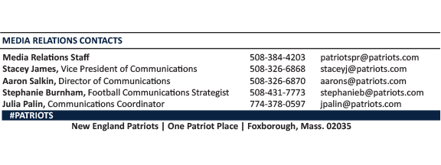
--PATRIOTS--

