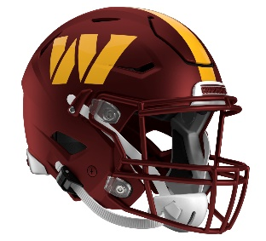 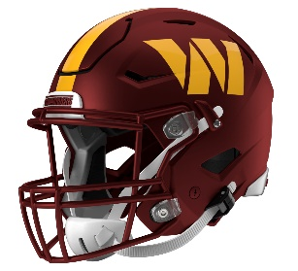

Washington Commanders

Postgame Transcript

August 8, 2025

**COMMANDERS QUARTERBACK JOSH JOHNSON**

**POSTGAME PRESS CONFERENCE**

**August 8, 2025**

**Q: Overall, how do you feel about the way you played and the way the game went?**

JJ: It's kind of hard to evaluate that right now when you lose like that. I'm just looking at it from a team perspective, honestly. So, just go back to the tape and then see what I could do better and where I can help be a better leader for the young guys so we can just come out the next game and play better.

**Q: Could you talk a little bit about what was happening out there? What did you see overall from this offense?**

JJ: We did some good things, but good in this league only gets you so far. We’ve got to put drivers together, and we’ve got to finish them. We can't shoot ourself in the foot, and we’ve got to – it's a challenge in this league to go put long drivers together without making mistakes, and that's something that we all can grow from as a unit to understand what it takes to be successful. I look forward to the next game because I think we'll have a lot of growth as a unit.

**Q: As somebody that's been through a lot of training camps and preseason games, what do you say to the young guys that this might be kind of their first action and it goes this way?**

JJ: Prior to the game, I just try to be calm in my actions, kind of be myself. But I think they'll learn a lot from this. The conversations and the details will probably pick up a lot more. I went through that when I was young. Once you see yourself on film in a real game and then understand the coaching aspect, how detailed I was on my assignment. I think everybody will come out with another level of understanding, and then we'll grow. Like I said earlier, we'll grow as a unit, and the conversations will probably be a little different, too.

**Q: As far as the positive things, did you see anything carry over from Wednesday's joint practices at all?**

JJ: I saw a lot of guys make plays. A lot of young guys, so many guys not playing, especially the receiver group. Some guys just got here, some guys, this is their first opportunity. Lineman were rotating around. There's a lot of moving parts, which comes with this league, but guys made plays. We’ve just got to be able to stack them, and we can't shoot ourselves in the foot. We’ve got to be able to consistently finish drives and do our part of the three phases of the game to make sure we give our team a chance to win.

**Q: You had a nice connection with Ja’Corey Brooks tonight. What's he been showing y'all throughout camp?**

JJ: Corey just comes in and works, man, every day. On the first day he got here, he's just been working, he just shows up, and he’s where he's supposed to be. He gains confidence in the quarterbacks; he makes his plays when they come. You just see the opportunities are going to keep coming for guys that do that.

**Q: Was it the little things that weren't being executed, or was it multiple things that just weren’t clicking tonight?**

JJ: I mean, it was a multiple. We can't turn the ball over, we can't have penalties. On the offense side, I'm not on the defense, I'm not on the special teams. I'm pretty sure they're going to say the same thing. We just, as a unit, as a team, we’ve all just got to play together. It's three phases of football in the NFL, and every phase is important. I understand that now being a veteran guy. So for me, I can just only focus on what I'm in and helping the offense. For offense, we can't have penalties, we can't have turnovers.

*Transcripts are provided by the Patriots media relations department as a courtesy to the media and are edited for readability. All press conferences are posted and archived in their entirety on patriots.com. The duplication or posting of this transcript in its entirety as original content is prohibited. Media are encouraged to link to the complete transcript on patriots.com when sharing full quotes with their audiences.*

**MEDIA RESOURCES**  
[Schedule](http://www.patriots.com/schedule-and-stats) | [Roster](http://www.patriots.com/team/roster) | [Videos](http://www.patriots.com/latest-media) | [Photos](http://www.patriots.com/media-center/photos/latest-photos) | [Audio](http://www.patriots.com/media-center/audio/latest) | [Media Website](http://media.patriots.com/Public/index.cfm?ac=home&CFID=38907286&CFTOKEN=938b1f105fd060-40635341-19B9-B7E8-F0ACAE9ADBEEE9EB) | [Twitter](https://twitter.com/patriots) | [Facebook](https://www.facebook.com/newenglandpatriots/) | [Instagram](https://www.instagram.com/patriots/?hl=en)  
Social: @Patriots | #PatriotsNation   
  
**--PATRIOTS--**