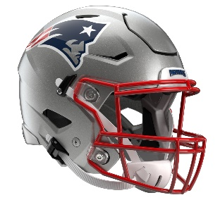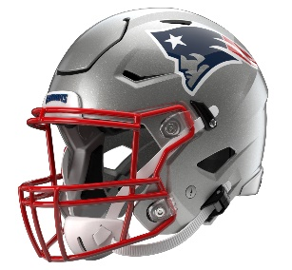

New England Patriots
Postgame Transcript
August 8, 2025

PATRIOTS QUARTERBACK DRAKE MAYE
POSTGAME PRESS CONFERENCE
August 8, 2025

Q: A thought on getting out there, stadium, Tom Brady night, the game action, just your thoughts on what you were able to accomplish?

DM: Yeah, shout out to the fans; that was a great turnout. It felt like a real game atmosphere. You get the same jitters going out there. Obviously, a big celebration for No. 12 [Tom Brady]; that's pretty cool statue they put out there. I was able to listen to a little bit of his speech; it was pretty cool. Honoring him and what he's done for this organization speaks for itself. But for the fans tonight, how about that? They showed out. I think what the guys did tonight, had everybody playing, playing hard, blocking, tackling, running around for full four quarters. I thought we kept playing, and I think we're kind of starting to build something, that we're going to start to build an identity. That's what coach is talking about, and I’ve got to do my part of protecting the football.

Q: I know you were very complimentary of Efton Chism [III] over the course of the spring and during OTAs. I know you guys didn’t have a chance to connect tonight, but from the sideline, what did you see from him and maybe his overall growth over the course of the summer?

DM: Yeah, he's a baller. I mean, he loves coming up and asking me questions about routes and things. He loves talking football. He's just a football player. You saw tonight, making plays. I’m glad he got in the end zone, and he almost got in the end zone again on the screen. He got chased down, but yeah, just blocking hard, doing all the right things. That's what we're preaching in the offensive room: keep doing things the right way, keep showing up, and you're going be rewarded.

Q: How disappointing was it to start with that fumble on the first drive you went out there?

DM: I was excited to get out there. TreVeyon [Henderson] takes it the 100 yards. It was pretty sweet. But yeah, you got a little bit of a drive going, third down. Yeah, just can't do that on my first time out. It definitely put a damper. I’m glad we responded well that next drive. But yeah, at the same time I'm glad it's something that I can control, but at the end of the day, you just can't put the defense in that position when games matter during the season. I told those guys it's on me. We’ve got to get back out there, and I’m glad I was able to get another series going.

Q: Drake, I imagine, especially as a quarterback, one of the top priorities in the preseason is avoiding contact. When it comes to using your legs, how much is the balance of, ‘I don't want to take off running and get too much contact,’ versus, ‘Well, if they're going to give me all that green grass, I’ve got to take it?’

DM: When they play man or they're down in the red zone, sitting back in zone, playing two-high, I’ve got to play football. That's my natural instinct. Obviously, you wish you could have hit some more passes, but at the same time, I thought we were running the ball well all night. There's an even balance of them accounting for me being able to run a little bit. I thought I got down on the first third down scramble, and then in the red zone, like I said, I’m going to go out there and play football.

Q: Take us through your reaction to seeing TreVeyon Henderson on that first play just take it 100 yards on that kickoff return?

DM: I think it's different with the kickoff rule now. Teams are going to want to tackle and not get 35-yard line. It's going to be a chance for some returns. Man, he's like a lightning bolt. I saw the crease and knew he was gone. So, it’s pretty cool that the first time he touches the football, it's a touchdown. Credit to the guys that did the blocking up front. That's special teams, and you emphasize all three phases. I think special teams has got a chance to be big for us this year.

Q: Back to the end of the first drive. Plays like that where you're trying to extend, do you feel like that's more just instinct like you were talking about, reflex, or is there a deliberate thought on that play of what you were trying to do?

DM: Oh yeah, it's instinct. It was the first time I've gotten hit since, shoot, back in Week 17. It's instinctive. I try to do my best and not get hit, but I'm going to do my part of standing there, delivering throws, and I know it's going to happen. Yeah, I think it’s instinctive, just playing football. Obviously, try to get the ball in the other guys' hands because they're better runners than I am, but just keeping the defense honest.

Q: In your first answer you mentioned the optimism you have with the group this year. Is it possible to have a sense for who and what this team is this early, and what's driving that optimism?

DM: Yeah, I mean, you’ve just got to continue to work at it every day, every week. Learn from it, learn from the tape. That's the biggest thing I've seen with these guys, they want to get better. They're asking questions. It’s a lot of football talk around in the locker room. I think that's just something you like seeing. I think the optimism for me is these guys, like I said in the previous one, we want to win. It starts with the head coach, the intensity. You see the guys up front. First offensive line group, that wasn't even me. I was tossing it, handing it off, watching them kind of set the tone early up front. That kind of gets me excited and gets me pumped up. You see guys talking trash until the whistle. That’s what you want. That's what you want around the locker room. You want those guys, and it's easy for me to get excited playing with guys like that beside me.

Q: When you think about Rhamondre [Stevenson], TreVeyon and Antonio [Gibson], how would you sort of describe the way they complement each other from your view?

DM: Yeah, I think it's tough on the defense. They all can make you miss. They can run over you. They can catch balls out of the backfield. So, it's going to be challenging for us on when to use them, how to use them, getting them the ball. So, we’ve got to get those guys open in space. They're great football players. You see two of them on the kickoff return; I don't know who they're going to kick it to. Both of them had pretty big ones tonight. I’m excited to have them beside me. I think the best thing about them, they're smart. They're good in pass-pro, running the football, that's obvious. But routes, and I think in pass-pro, they're willing to back. That's something you look for in a quarterback. Is he going up in the A gap like, ‘Man, I’ve got to go do this.’ These guys are going like, ‘I'm going to protect the guy behind me,’ and that’s what – like I said, it's pretty cool and fires me up. Thank y'all.

Transcripts are provided by the Patriots media relations department as a courtesy to the media and are edited for readability. All press conferences are posted and archived in their entirety on patriots.com. The duplication or posting of this transcript in its entirety as original content is prohibited. Media are encouraged to link to the complete transcript on patriots.com when sharing full quotes with their audiences.

MEDIA RESOURCES
Schedule | Roster | Videos | Photos | Audio | Media Website | Twitter | Facebook | Instagram
Social: @Patriots | #PatriotsNation
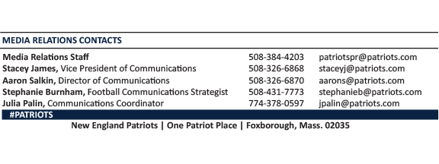
--PATRIOTS--

