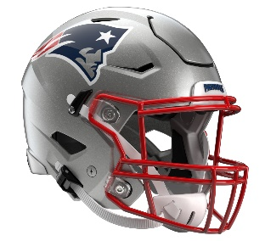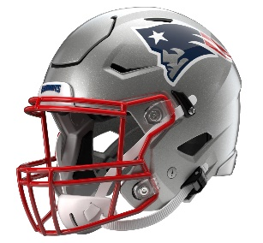

New England Patriots
Postgame Transcript
August 8, 2025

PATRIOTS HEAD COACH MIKE VRABEL
POSTGAME PRESS CONFERENCE
August 8, 2025

Q: I'm guessing you don't want us to make any bust for Canton yet for TreVeyon Henderson. I'm guessing you think he might have gotten off to kind of a good Patriots debut today and got the team rolling?

MV: I think that was one of the phases that we talked that was going to be so critical and that's hard to really rep full speed. We got a few of them against Washington. I think we saw some things that we can improve on, and that's exactly what we did. I think TreVeyon read it out, hit the hole and everybody else blocked and finished and did all those good things. So, it's a step in the right direction. I think it's exciting any time that you can – we talk about how critical a phase of a game is going to be and to come out here and be able to work on it.

Q: It looked like Efton Chism [III] got off to a good start tonight. What did you see from him that maybe stood out?

MV: I think his play strength stood out to me, just from the sideline. I think it's the way he blocks, his ability to catch the ball in traffic. The ball was basically tipped or bobbled coming out of Ben's [Wooldridge] hand, kind of ran through a tackle, ran through contact, and we threw him a screen. So, those are all positive things. I think his play strength to me is what stood out.

Q: Thoughts on Drake [Maye]'s performance. I am sure the turnover probably annoyed you with what he did.

MV: Are you asking and answering a question at the same time? Is that what you're doing?

Q: I got you. Your thoughts?

MV: I would say you about summed it up. That's a bad decision. I think we're going to need better from him, and I think he knows that and that's obvious. So, it wasn't there, and we just have to be able to find a way to get rid of the football or take a sack, punt and play defense. But to the defense's credit, they forced a field goal I think that was missed maybe. But it was a sudden-change opportunity.

Q: DJ James continues to have a solid summer. Your impression of him, the interception tonight and the work he continues to do for you?

MV: I think it's always exciting to see players that take advantage of opportunities. Since DJ was one of the players that was here for rookie minicamp, I would say since that day, that weekend, he's continued to improve. I think he's taken advantage of that. So, I'm always for players that get better, take coaching. It's on them obviously to improve. So, that's all to DJ's credit. So, I'm excited for him that he can put in the work and start to see it translate onto the field.

Q: I can't imagine a lot of instances of you leaving, going outside the stadium 90 minutes before kickoff, but how important was it for you to be at Tom's ceremony? What was it like for you being there and getting quickly back into game mode?

MV: I think it made it a little easier just because it's a preseason game, and there's maybe probably not as much going on. I mean, there's still the schedule and everything, meeting with the officials, the team and the coaches. But I mean, it was always important for me to be out there. You saw the amount of people that were there to support him, people on the Commanders' side, former teammates. Just having somebody like that be a part of this organization, pretty unique, pretty special. So, I’m glad that I was able to be a part of it for a little bit.

Q: With Will Campbell and Jared Wilson, I’m curious how do you thought they did on the left side tonight? It seemed like on the fumble, they might have missed that block, but at the same time, Will Campbell – and they were pushing guys forward, so just how you thought they did overall?

MV: I think the play demeanor showed. I think there was a game, maybe a pass rush game, it looked like to me, and those are some things that we'll continue to work hard on. We were able to pick them up in the practice. They ran a few of them over there against us in practice. We just have to be able to carry that execution into the game. But I certainly did see their play demeanor kind of stand out, and I think that's a good place to start, is with that, being downfield, finishing through the whistle and everything we embrace that here.

Q: We saw Ja'Lynn Polk leave for the locker room after the carry. Just curious if there’s an update on him?

MV: No, no update right now. He'll get more testing and see our doctors, and he wasn't able to finish the game.

Q: Obviously you want to establish consistency in the preseason and in training camp. So, how important is it for you that on this first game only two penalties for 15 yards?

MV: Well, we had a couple that were really offsetting. We still fouled; it wasn't like we were really, really clean. I thought operationally, we were pretty good. I felt like everybody was on the same page, substitution, getting in and out of the huddle. They don't huddle; they sub. Sometimes they stand over it, and sometimes they don't. I felt like defensively, that was a good challenge for us to be able to play a game like that with a team that really doesn't want to huddle. But when you can have that many — we had a few kickoff returns and did not have any penalties there. We had the one that was offsetting on the punt. Those are critical because there's so much field position that gets changed when you have penalties on punt returns and kickoff returns. So, it's a good start. It's a good start for everything that we were talking about. It’ll give us some more to coach. We have to tackle better, and we’ll have to throw the football better going forward, but I thought this was a good place to start.

Q: Javon Baker made a couple of special teams tackles. I thought you were encouraged by that on the sideline, but is it good to see someone who's trying to contribute in more than one phase in terms of trying to make the team?

MV: Yeah, I think that's fantastic. When you have players, especially receivers, that can create a role, that can help you, be big, physical, everything that we see out of Javon as a receiver, when you can embrace that and they can embrace that as special teams players, guys that are big, physical, fast and willing, that translates to special teams. So, excited and just happy for Javon just being able to go out there and contribute. When you do those things, your teammates get excited. Hopefully his confidence continues to grow.

Q: You mentioned the passing game is something you can improve. Obviously it's early, but what do you think contributed to that, whether it was separation –

MV: I mean, I think the way that the game kind of unfolded with the kickoff going for a touchdown, a defensive turnover. I felt like we had some opportunities. Maybe the ball was batted. I thought we had C.J. [Dippre] for a touchdown there. He was open, then just the protection, I guess, on the third down. So, it wasn't like we had a whole lot of opportunities early. We were able to kind of convert and score running the football. Drake scrambled, right? So again, I'm all for him using his ability to run when it's there. You saw him slide, and you saw him be able to run in the end zone. So, maybe just kind of how the game unfolded early. We hit some passes late. I think Ben settled down. I was excited to see him settle down and hit some passes. John Jiles, who busts his tail to block and play special teams, had a huge catch there. I felt everybody played, which I'm excited for. We talked about how there were some players that didn't get to play or practice on Wednesday, and they were going to get an opportunity on Friday night. I was happy to see them take advantage of it and proud that they could be excited about it. Thanks, guys.

Transcripts are provided by the Patriots media relations department as a courtesy to the media and are edited for readability. All press conferences are posted and archived in their entirety on patriots.com. The duplication or posting of this transcript in its entirety as original content is prohibited. Media are encouraged to link to the complete transcript on patriots.com when sharing full quotes with their audiences.

MEDIA RESOURCES
Schedule | Roster | Videos | Photos | Audio | Media Website | Twitter | Facebook | Instagram
Social: @Patriots | #PatriotsNation
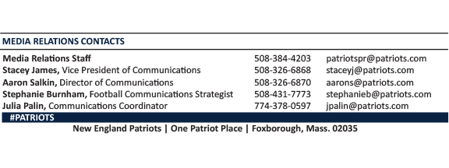
--PATRIOTS--

