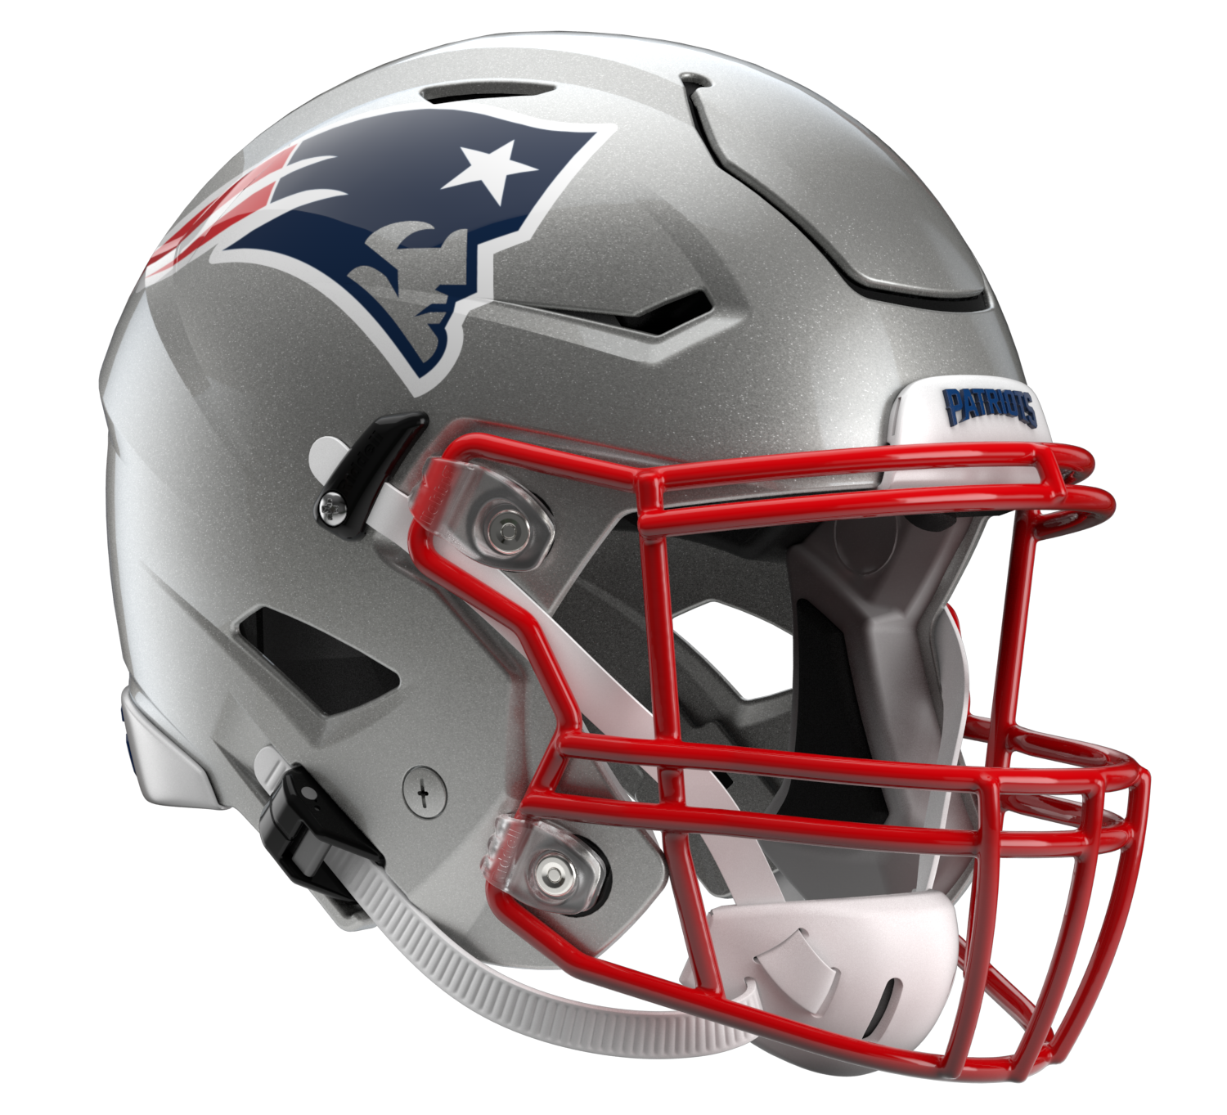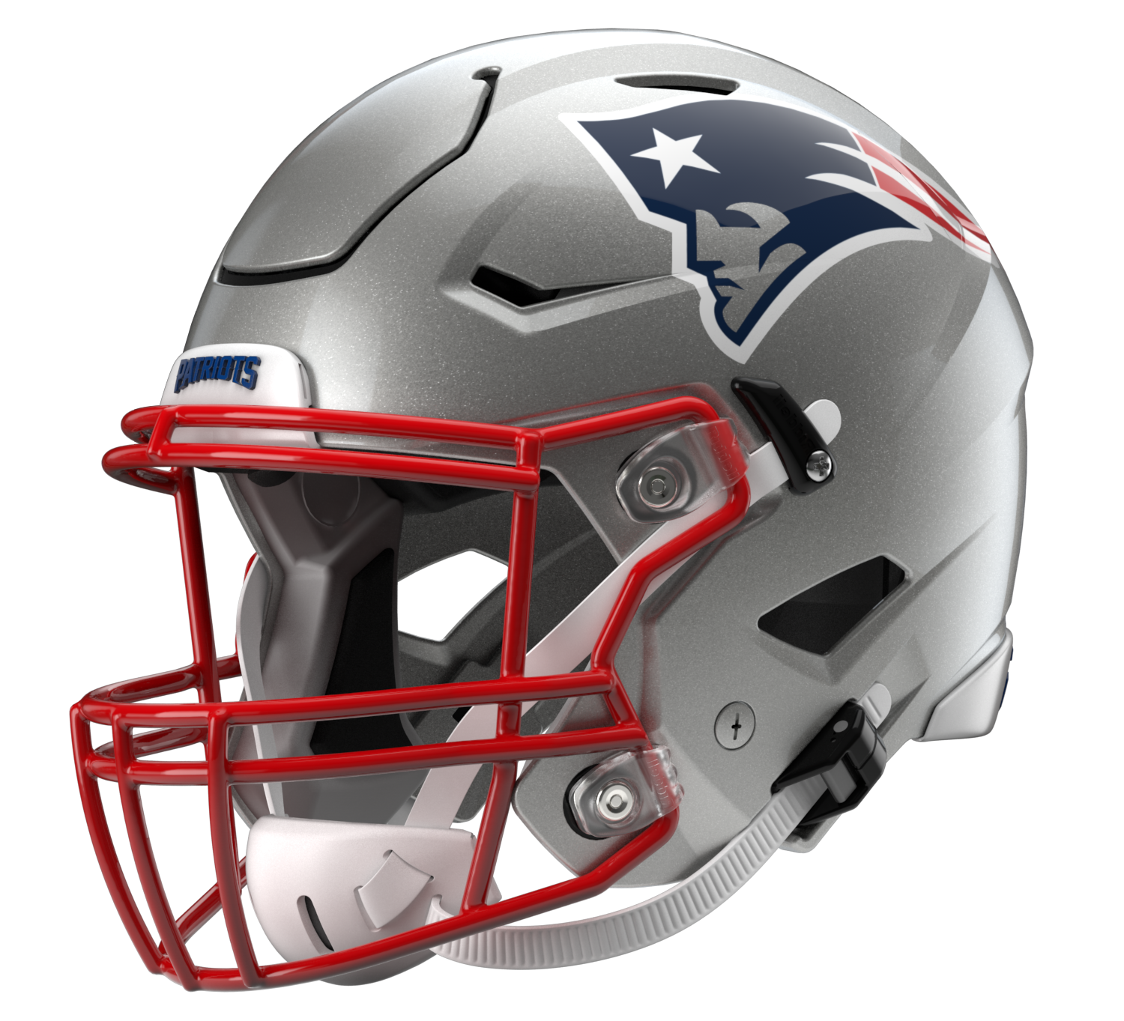

New England Patriots
Postgame Transcript
November 6, 2022

The following FastScripts transcript is provided by ASAP Sports. Please note that for speed and efficiency, this transcript has only been lightly edited and the final edited version of this transcript will be circulated at the end of the night.

PATRIOTS QUARTERBACK MAC JONES
POSTGAME PRESS CONFERENCE
November 6, 2022

Q: How do you sort of sum up the day for the offense today?

MJ: Yeah, I think football is a team sport, and we got the "W" today against a good team overall. Obviously, talked about, you know, a lot about last year and how we felt after the game. Felt like we came in and played as a team. Obviously, offensively, want to do even better, and we will. We've got to look at the tape to kind of figure that out. Defense played great. Uche, three sacks; Judon, three sacks; Bentley, sack, D-Wise, half a sack. Sacks everywhere. So we kind of knew our defense was going to control the game, given the circumstance with the other team, and that's a good defense that we went against. I think there's good players all around. I don't think they did anything crazy in the game that we didn't expect, but we’ve got to hit our targets a little better here. But no turnovers from my part, which is an improvement. But, you know, we put the two fumbles on the ground, which we'll fix. That's one of the things we talked about was just controlling the ball and not turning the ball over. So did a good job there. Obviously, we want to score more points in the red zone. I'm not sure how we finished there, but definitely had some short fields that we want to score on, and I thought we fought hard and won the game. In the NFL, it's hard to win, you know. It takes everybody. You know, like I said, last year was a different story. We won this year. That's all that really matters.

Q: Mac, obviously, like you mentioned, you guys got the "W", 4 of 5 now. What do you take from yourself and that offense as you go into the bye week. What would you like to accomplish as you go into the bye week for the final eight games of the season?

MJ: Like I said, we want to play our best team ball. Our defense and special teams are playing really well. We're playing good at spots, but we need to continue to go up here and stop riding the wave, you know, which we will. I think we have really talented players at every position. Even today, the guys that stepped up with, I guess, what was it, four or so starters out of the game, it's pretty impressive to go in there and not have a lot of drop-off and beat a really good team. So we'll look at everything. I know our coaches have been grinding it out, doing a great job, putting us in a position to succeed. We've got to go out and execute a little better. The bye week or whatever you want to call it is always a good time to physically get yourself back and then obviously mentally. And then X’s and O’s-wise, see what you're doing well and what you're not doing as well. I know our coaches will do a great job grinding it out, and we'll be on the same page.

Q: Mac, obviously, you want more touchdowns, but you talked this week about not going broke by making sure you're taking the profits. How do you feel you and the offense did that today on the whole? Especially against a challenging defense like the Colts.

MJ: Yeah. I think we definitely want to move the ball. And when we get the ball as an offense, we want to score on every possession, and we want to score touchdowns. And sometimes when we don't do that, we get a little frustrated, myself included. But at the end of the day, it's about controlling the ball. When we don't turn the ball over, our statistics are really good to win the game. Sometimes it's hard to realize, but we talk about that internally all the time, and when we do that, we usually win. So definitely some things I'm sure I'll see on film that you want to have back. At the same time, you've got to move the ball, and we've got to eliminate some of the negative plays. We're just in long yard situations way too often. It's the NFL. These guys are pretty good. If you put yourself behind the sticks, your percentages plummet. It is what it is. You've got to fight through it and figure out a way to be better on first and second down. That helps on third down.

Q: Two things off that. You mentioned guys were talking about the negative yardage or penalties. Also the consistency factor. How do you get better in those two areas, specifically?

MJ: I think it starts in practice. I feel like we have a really good group of guys, and we need to make this our thing. It's, all right, we need to take it personal for the offense that we're getting too many penalties or, you know, missing a guy here or there. Whatever it is, like, we need to just nail that down and find out the issues and just create, you know, there's problems, obviously, clearly, and we just want to fix anything with a solution.
I feel like we've done a good job of that, but we really need to pick that up to beat some really good teams coming up. We know what it takes. We have good players. We've got good coaches. So it's a group effort. Everyone being on the same page and coming together and every day at practice, that's all you can control, right? You have to line up, do your job, whether that is block somebody, whether I have to hand it off, throw it, whatever, change the play. So it's all an individual effort. But at the same time, when you get 11 people on the same page, all that stuff will look a lot better.

Q: Mac, you're now nine games into playing with a new coaching configuration on offense. How do you describe where you, Bill, Matt, and Joe are in terms of being in rhythm and accomplishing what you want to accomplish?

MJ: Yeah, I think we were focused on today, and today we kind of hit some of our targets. But wanted to hit even more of our targets. They've done a great job preparing us for the games. Coach Belichick in our meetings and stuff, anything he sees, he's always providing that information for us as quarterbacks from a defensive perspective, which is great. That's continued, and that's helped me a lot. With Coach Patricia, obviously, we've grown together and he's done a great job. He's a great leader of men. He loves football just like, you know, all of our coaches, and he's going to give it his all every day from 6:00 a.m. until whatever it is, 2:00 in the morning. So I know that they're all going to give their all. And Coach Judge, same thing. He's here early trying to find ways to help me and trying to, you know, help me play as best I can, and we're still growing together. It's not going to be a perfect picture every play. But as long as I'm doing my part, the guys around me are trying to do their part, we'll be in a good spot.

Q: Mac, admittedly, it's easy for us to say, oh, there's a guy on the other side of the field that might have been open or something like that on plays. When you come to the sideline and see it on the stills or the film, what as a quarterback can you do to make sure that maybe you open a different direction or something like that on given plays?

MJ: I'll have to look at it. I look at the stills and stuff, but I don't look too much into it. It's false reality. So just trying to see what the defense did. That's all you can really control. And I'm sure there's some plays, but it's all about where your eyes start, right, as a quarterback. What you're being told and where you're looking.
Sometimes you miss things that people – you don't know if you missed it or not on the field. You walk off and are like, darn, I looked at the picture. Looked like it was there, but my eyes were starting where they were supposed to start. Sometimes that's how it is. A lot of those sacks too, it's just on me to get the ball out to the open guy. Doesn't have to be an explosive play every time. Like I said, I thought the guys stepped up with a lot of our – some of our starters out. That was really good. But got to watch the film and see how it really was.
It's all about timing and footwork. Does it match up to the play? Does your drop match up to the route to where your eyes are? Like I said, there's good players on the other side of the ball. There's a clock going on in your head. You've got to be ready for it. Can't sit there and hold the ball all day.
Q: Mac, to follow up, in the fourth quarter, there was a scramble play. Looked like you had the touchdown right there, one defender to beat, but didn't happen. Can you take us back to the play and explain your thought process there?

MJ: Trying to think. I'll have to watch the film. There was somebody in front of me. Otherwise, I'd have gone in the end zone. Pretty simple.

Q: Mac, you see the emergence of Rhamondre. On the touchdown pass, it was a hell of a catch. What was it like in your mind to see him as a running back haul it in like that, and what has it meant for the offense over the last few weeks?

MJ: Rhamondre has done a great job. Damien not being out there, he's definitely carried the load there. JJ stepping in and making plays too. Just proud of those guys. We have a great group of running backs. Vinnie has done a really good job with those guys. They actually put two guys on him a few times. Still got open with two guys on them, which is cool. He's done a good job. He's a competitor. Quiet, but super competitive. He might not say it, but he is. He's done a great job and will continue to do that.

Q: Mac, Jonathan Jones had quite a day today. You go against him in practice every day. What have you learned about him as a football player?

MJ: He's done a really good job this year, playing different spots. Early on, he's historically been inside. He's done a little bit of everything and is a really fast, quiet technician. I think he has done a great job for us. He's a great leader on this team too. Whether that's just when we're talking to him one on one or he's talking to the defense, you can tell they all respect, him, and he has a very big voice in the room. Really happy to see him haul that one in. He's obviously fast so he's going to get to the end zone.

Q: Mac, as you head into the bye here now, you mentioned early down inefficiencies is something you want to fix. Is there anything that has your focus individually in the bye week, in addition to obviously getting away a little bit?

MJ: Like I said, the coaches will evaluate that. They always do a good job of seeing what we do well and sticking with it. What we don't do well, how can we do better. First and second downs is a big part of the NFL. I think really good teams are good on first and second down. Third down, they're in a better spot and convert more. You want to be above whatever percentage mark we set, and we've got to be better and extend drives that way.
Every drive can't seem like it's so hard to get yards. We've got to be able to skip some third downs and move the ball and get explosive plays. Once again, defenses are kind of trying to take that away, playing a lot of two-high coverage and trying to stop that. So it's a respect towards our skill players and the guys we have.

Q: Want to get your thoughts on Nick Folk. I know you said you want to put it in the end zone when you're close. Is it nice to know once we're here, we can at least get 3 because he's been so consistent?

MJ: Yeah, he's the man. I'm not going to jinx him or anything, but almost every time he goes up, he has the confidence to put it there. Great person, works really hard. Has played a lot of football and made kicks, and he'll tell you he's missed kicks too. I'm sure his journey, it's been up and down, but he's a great kicker, and you can tell that he's just been – can't miss. I don't know how to describe it. He's just great. We're happy to have him. Thanks.

Transcripts are provided by the Patriots media relations department as a courtesy to the media and are edited for readability. All press conferences are posted and archived in their entirety on patriots.com. The duplication or posting of this transcript in its entirety as original content is prohibited. Media are encouraged to link to the complete transcript on patriots.com when sharing full quotes with their audiences.

MEDIA RESOURCES
Schedule | Roster | Videos | Photos | Audio | Media Website | Twitter | Facebook | Instagram
Social: @Patriots | #PatriotsNation
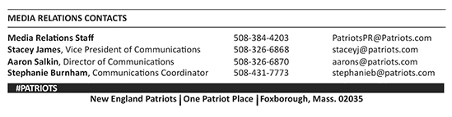
--PATRIOTS--

