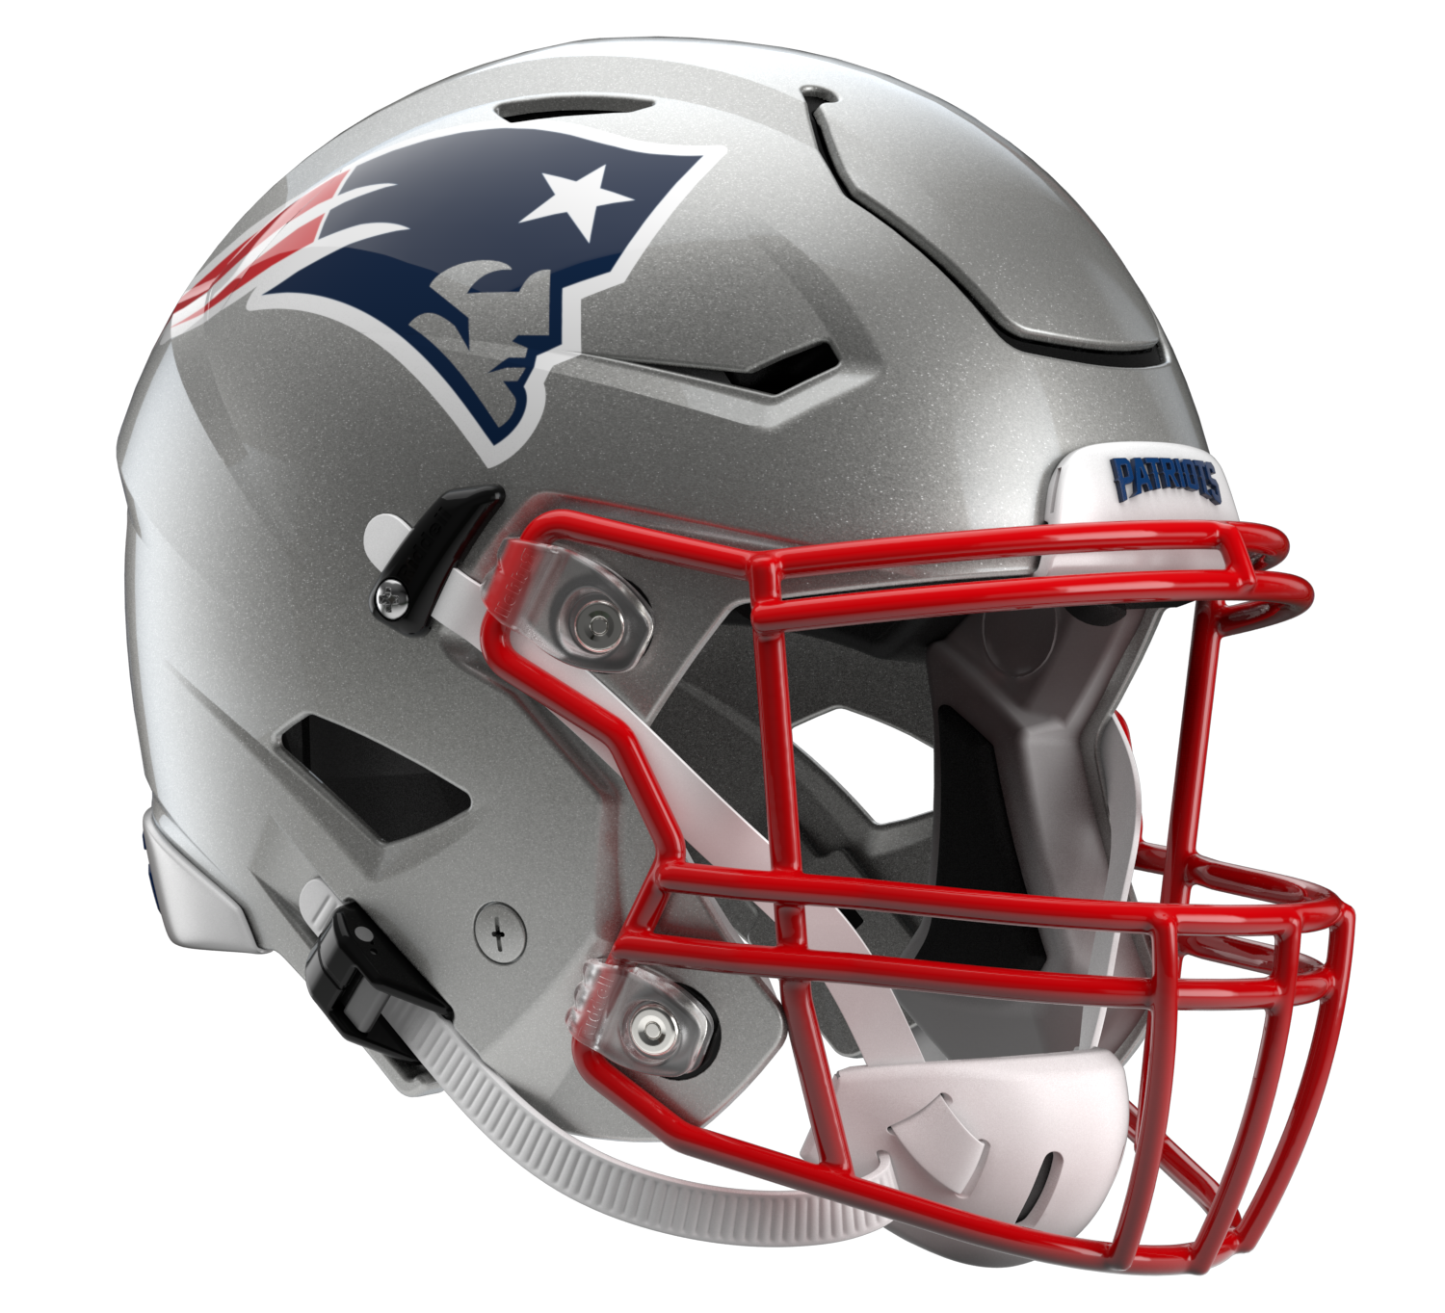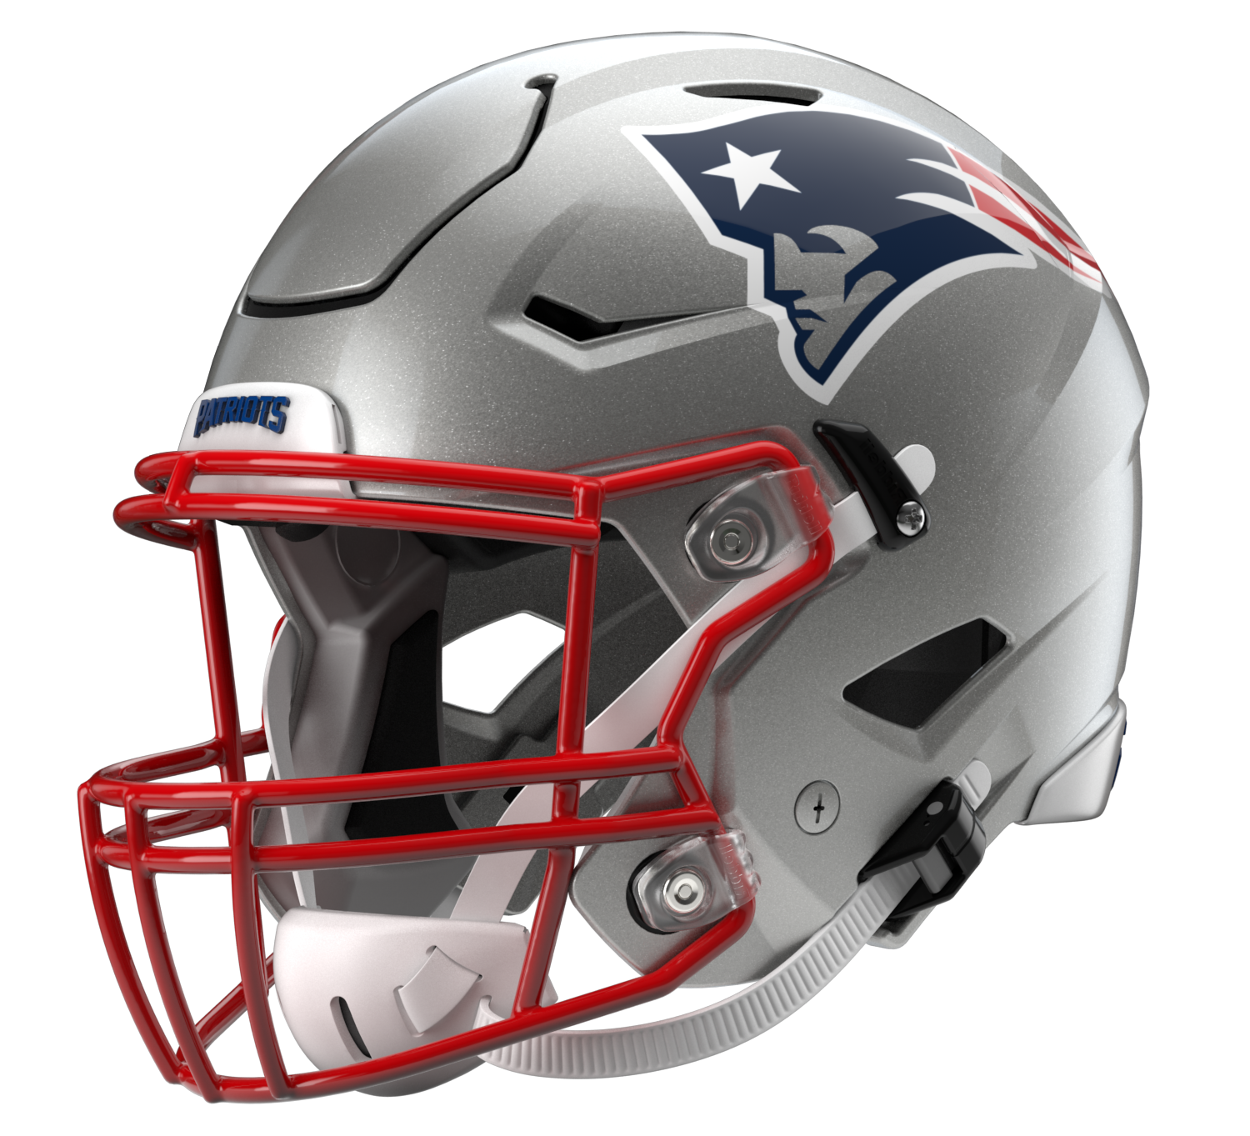

New England Patriots
Postgame Transcript
September 25, 2022

The following FastScripts transcript is provided by ASAP Sports. Please note that for speed and efficiency, this transcript has only been lightly edited and the final edited version of this transcript will be circulated at the end of the night.

PATRIOTS DEFENSIVE BACK DEVIN MCCOURTY
POSTGAME PRESS CONFERENCE
September 25, 2022

Q: You've been around this team for a long time, seen a lot of incidents involving the quarterback. What sort of impact does it have when the quarterback goes down like that, the uncertainty?

DM: It was at the end of the game. So evaluate it. There's nothing we can do. See what it is. Especially when it happens at the end of the game, no one knows. I don't think some people probably kind of paid attention because of the game. Obviously key player, key part of what we do. Have to evaluate and see what it is.

Q: Devin, you were able to sack Jackson four times and pick him off once. But would you consider it an unsuccessful day trying to stop this dynamic player?

DM: Yeah, I mean, that's the thing when playing against him. Stat-wise, overall, can look like you did some good things, but he changes games with a couple different plays. Some of those QB run plays at the end of the game were huge for them, changing the field, big gains. That's the thing, when you play against a team like this, an offense like this, we battled, we had some really good possessions, we had some good I would say back-to-back drives where we were able to get off the field. We had good moments. But against a team like this, an offense like that, it's 60 minutes consistently of trying to show up, doing a good job with some of the sudden change opportunities we had. One of the things we'll walk away with is just playing better in the red area.

Q: You've dealt with plenty over your years in the NFL, we don't know Mac's physical condition. If something changes, how do you rally around that and your level of concern for him?

DM: Yeah, I mean, just have no idea, so I couldn't tell you level of concern or anything because we have no idea if he would have went back in the game. Like we just don't know. We'll evaluate it, see what it is. We'll get ready to go next week to go play Green Bay.

Q: Obviously Mark Andrews is a very good player. What about the design of their offense, the way they use their tight ends, make the most of the packages?

DM: Yeah, I mean, it's an offense – I said it earlier in the week. It's like when you play the triple option in college, it's an offense that you don't see every week. It's the play-action, it's the threat of the QB run, the pistol formations you don't see all the time, then it's the tight end streaking across the middle. You have so much to look at, and that's what makes it tough. You put a good player in the middle of it like Andrews, who is fast, puts a lot of pressure on the defense because of his speed at tight end. He's a bigger guy. Especially in the red area. We talk about tight ends show up big-time in the red area. Lamar Jackson is also more dangerous in the red area to run the ball and score. That's what I was saying, we'll walk away and feel if we could have played a little bit better in the red area, turned some of those touchdowns into field goals, it could have helped us out a lot.

Q: Obviously you don't know anything about Mac's injury, but can you talk about his toughness.

DM: Yeah, I mean, he shows up, is ready to go each week. Obviously playing quarterback in this league, you take some hits. It's tough. You ask level of concern. I have no idea because I know if he has something he can go and play with, he's going to play with it. We'll have to see what it is and go from there as a team. I think we'll continue to rally around him. I think we've always talked about it my whole time here, it's always the next-man-up mentality if it comes to that. We'll wait and see what Monday and Tuesday look like. We'll get ready to go Wednesday for next week.

Q: On your defense, got to be a little frustrating that you limited the big plays, but still weren't able to stop them.

DM: Yeah, again, it goes back to the red area. When you play an explosive offense, you want to try to force them to drive the field. You got to show up in the red area when they do do that. Like I said, they're going to make some plays, and they did that. Andrews had a catch over me that was tough. Duvernay had a tough catch in the corner of the end zone. I think just playing better in the red area, kicking field goals, you got to limit. Give up 37 points, it's going to be tough to win in this league.

Q: You had some words during the week seeing from afar Lamar's growth. Do you see that with Mac? Were there moments where you can see that arc with him as well?

DM: I do. But I'm not going to lie to you, I don't evaluate Mac like at all. I think for us, like you just said, we're playing against Lamar Jackson. If I'm wasting any time to evaluate what Mac is doing, where he's at, it's going to be the worst out there. I think defensively our task is each week – this week Lamar Jackson, next week is Aaron Rodgers. I think that needs to be our focus and it has been. That will remain our focus, the quarterbacks we're playing against, leave Mac and the offense up to them.

Q: A lot of attention on the way the game finished. How nice was it to see Vince Wilfork get honored during the game and over the weekend?

DM: Yeah, I mean, he's meant a lot to me in my career. Obviously not even just him, him and his whole family. I've spent Thanksgivings there. I've spent different holidays with his family hanging out. He took me in just like a little brother. Kind of means I'm old that I played with a guy that's now in the Patriots Hall of Fame. It was cool to be there yesterday. I know more than anything, he would have loved for us to get a win. A true Patriot. Tough, but like you said, awesome to see a guy that meant so much to a lot of guys' careers and this organization to be celebrated and honored the right way.

Transcripts are provided by the Patriots media relations department as a courtesy to the media and are edited for readability. All press conferences are posted and archived in their entirety on patriots.com. The duplication or posting of this transcript in its entirety as original content is prohibited. Media are encouraged to link to the complete transcript on patriots.com when sharing full quotes with their audiences.

MEDIA RESOURCES
Schedule | Roster | Videos | Photos | Audio | Media Website | Twitter | Facebook | Instagram
Social: @Patriots | #PatriotsNation
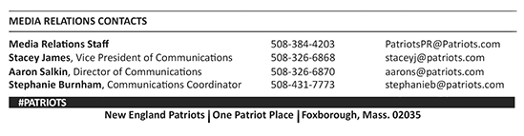
--PATRIOTS--

