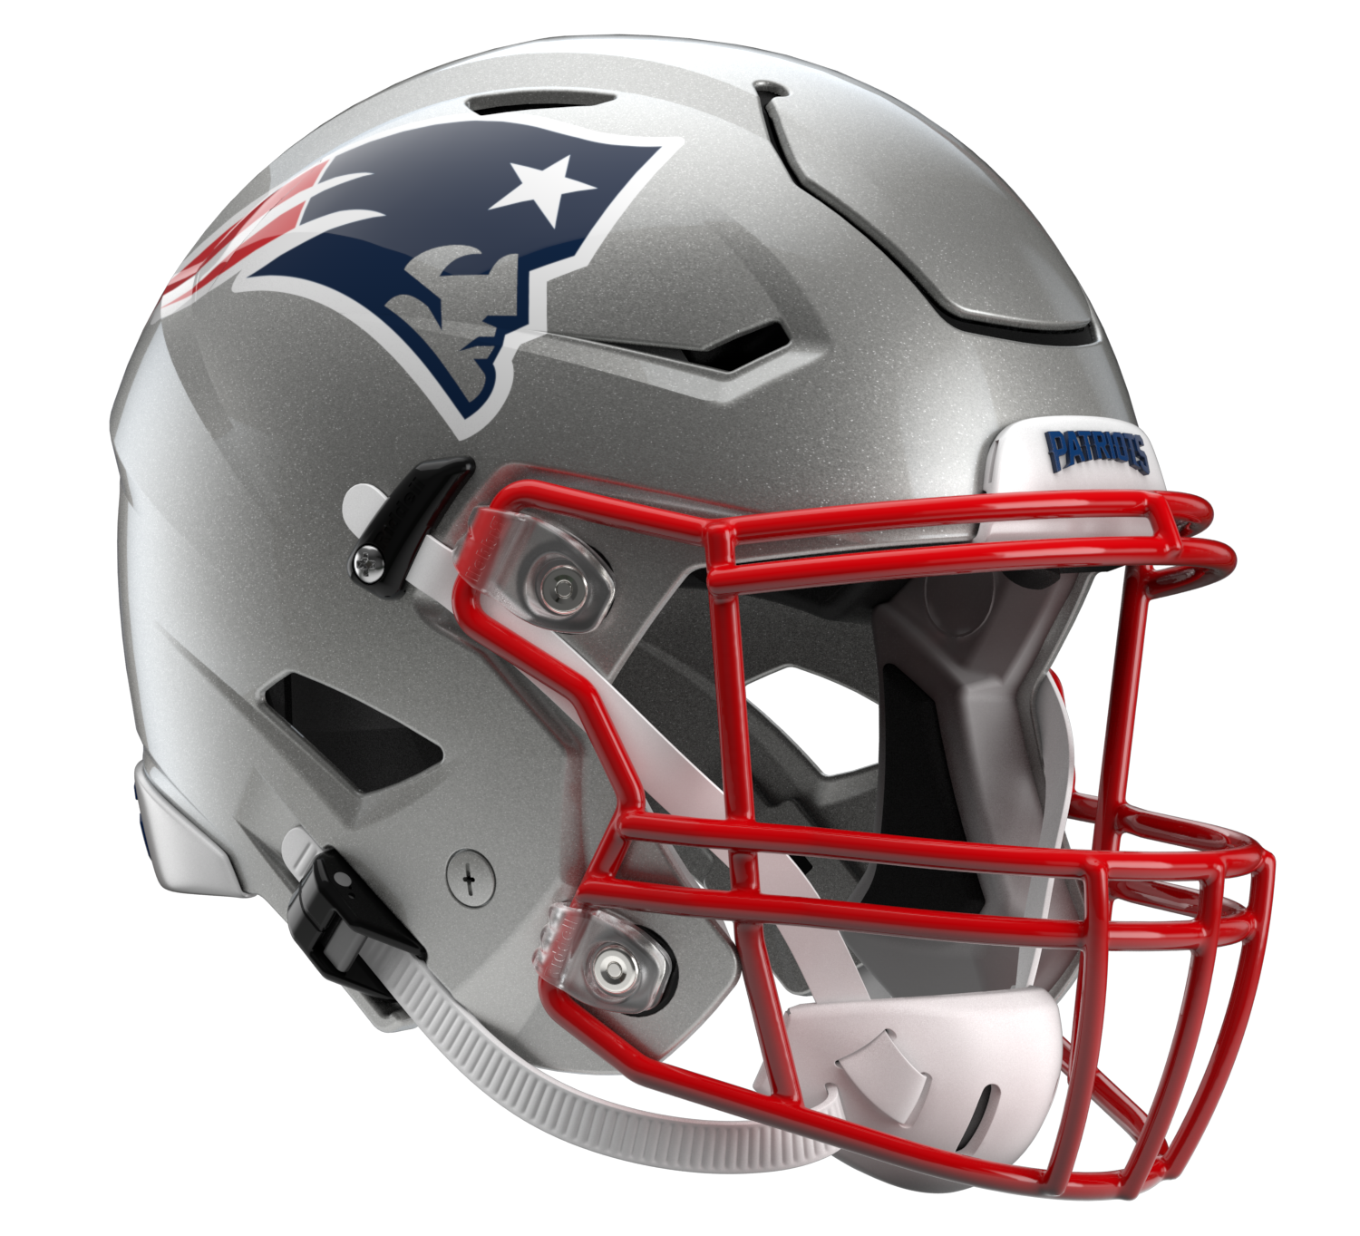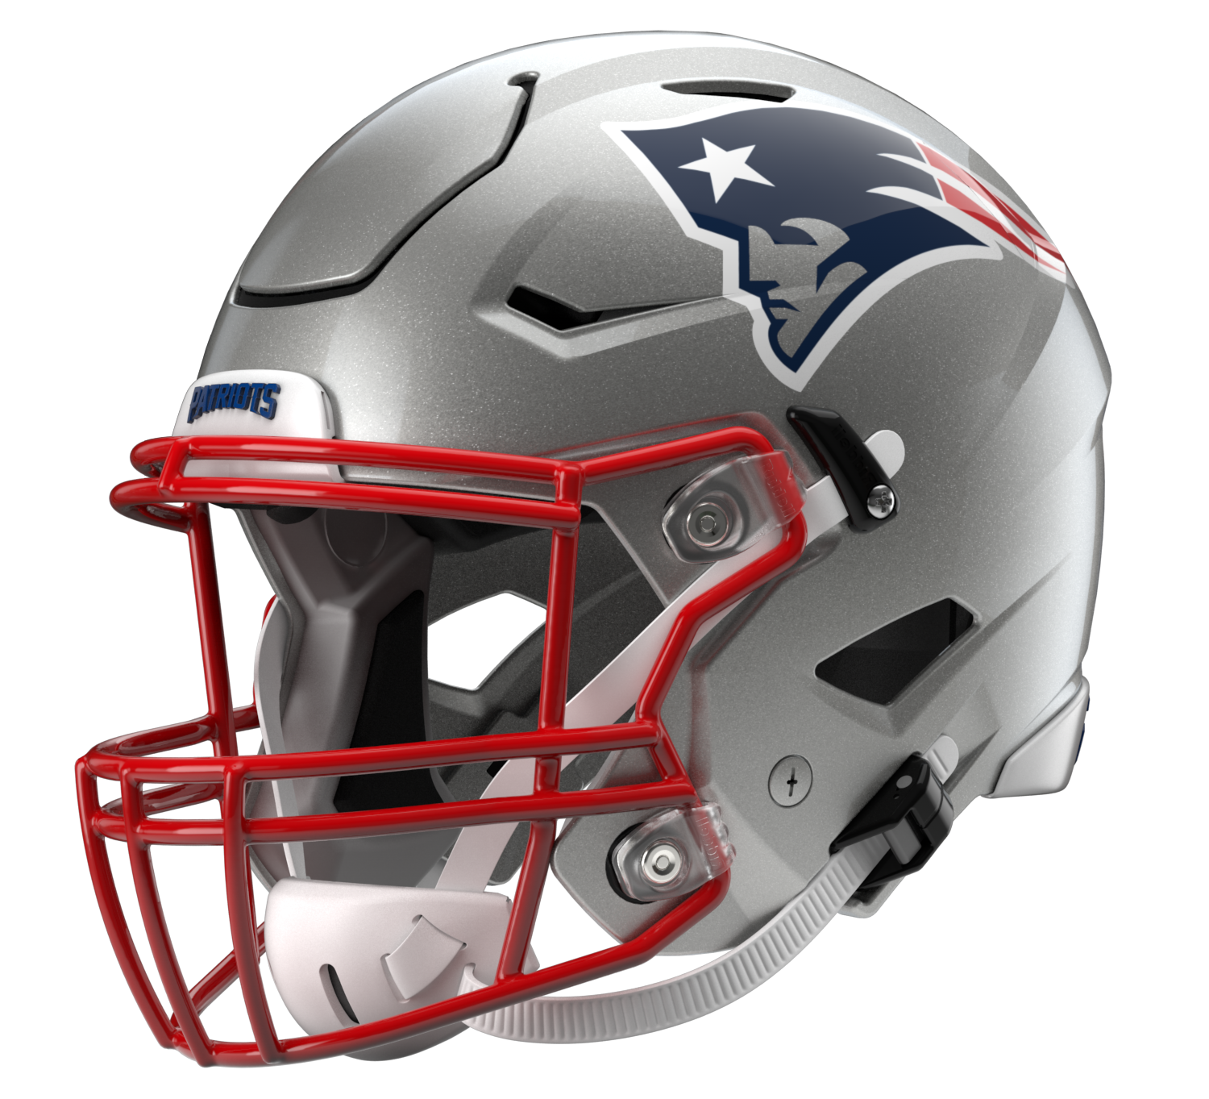

New England Patriots
Postgame Transcript
August 19, 2022

The following FastScripts transcript is provided by ASAP Sports. Please note that for speed and efficiency, this transcript has only been lightly edited and the final edited version of this transcript will be circulated at the end of the night.

PATRIOTS HEAD COACH BILL BELICHICK
POSTGAME PRESS CONFERENCE
August 19, 2022

BB: Well, it was good to see our guys go out there and compete tonight. I thought that they in all three areas put on a good effort. Certainly there's things we can do better and clean up, but I thought there was progress. We had a good week here, a couple good practice days against Carolina, and then some of the guys that didn't get as many reps in practice got more reps tonight, so think we got a pretty good look at everybody. We'll look at the film here and see how things went. You know, another step in the process, and we'll just keep grinding it out here. Look forward to the week in Vegas, working with the Raiders and Josh [McDaniels] and the coaching staff out there. Just another opportunity for us to continue to build and evaluate our team. Feel like we had a good week here. Ready for another one.

Q: Mack Wilson has made a pretty big difference since he's come here. How has he looked in the last two preseason games for you?

BB: Mack has really come on through the spring and then in preseason. Certainly when the pads come on, he's an explosive player, contact player, and adds speed to our team on both defense and the kicking game. Good to have him, and I think he's getting a little more comfortable out there each day, each game with the guys he's playing with, and the communication, things like that. He's been a good addition.

Q: Last week you described the process of finding an offensive play caller, you said you were in the middle of a process. It looked like Matt Patricia was calling all the plays tonight. Would you describe that process for selecting someone complete at this point?

BB: No, it's still a process.

Q: On Kendrick Bourne, why didn't he suit up tonight?

BB: He wasn't available.

Q: The third drive offensively, what did you see that sort of got the offense into a better flow than the first two?

BB: Well, we just missed a couple plays on the first two. You know, that's football. I don't think there were really any big problems, just our execution and just – if we don't get that first down, then obviously it's a short drive.

Q: Just to follow up on that, to have that group cap it off on that third drive, how significant is that to just – I guess it was Mac Jones, some of the players stayed on there, but to have his night end on that, how significant was it?

BB: Yeah, good to string some plays together. Wish we could have done that earlier, but it was good to finally get that done.

Q: As someone who very much respects special teams and the punting game, how do you feel that the special teams fared tonight?

BB: You know, we had our moments. Didn't do a very good job in the return game, punt return game. That troubled the gunners. Didn't handle the ball well. Anytime you don't handle the ball well, you're not going to have a good return game. Our coverage was okay. Made a couple field goals, missed one. Certainly could be better. We can coach it better. We can execute it better. But the punt return game was disappointing. We didn't really do anything on that. Got a break when they had an unsportsmanlike conduct penalty and they added 15 yards on to the last return there, but it should be better, needs to be better.

Q: How would you describe the communication aspect between play caller and quarterback tonight?

BB: How would I describe it? Normal.

Q: Cole Strange played well into the third quarter today. What did you see from him?

BB: Well, again, for all the guys that don't have a lot of experience, certainly he would fall into that category, just the more playing time, the opportunity you get, the more they learn, the more they build their conditioning and see different things from the defense. Carolina did a nice job tonight of mixing things up with some pressure, some man pressure, some zone pressure, mixed the fronts up. They have a good defensive front, which is good for our offensive line to see. Obviously we had some guys out. But that gave some other players some opportunities. Again, the more snaps those guys get, the better they get and the more chance we have to evaluate them, and hopefully we'll be able to get our group together this week in Vegas and try to play with as many players as we can. There were several players that we would have liked to have seen out there tonight that weren't available. That's usually the way it is. But the sooner we get them back out there, the more consistency we'll be able to build.

Q: Was Matt Patricia calling the offensive plays the entire game tonight?

BB: Communication with the quarterback, yeah. As far as calling the plays, there's a whole other process on that, but yeah.

Q: How would you evaluate how he did communicating plays to the quarterback?

BB: It was normal. It was fine.

Q: Is the process still between you, Joe and Matt when it comes to selecting the plays?

BB: No.

Q: So is it falling to anybody else or it's between you three?

BB: It's a process.

Q: Talk about what you've seen from Lil'Jordan Humphrey throughout training camp and tonight. Looked like he made some good plays in the passing game and in the kicking game.

BB: Yeah, he's made some plays for us since he's been here. He's a big kid that is tough and has very good hands and is kind of a big receiver, tight end-ish type of guy, has a good feel, very good instincts in the passing game, handles himself well in the middle of the field with linebackers under him, over him, in between him. Kind of does the right thing there and helps the quarterback out and is a big target. He gets some tough yards after the catch. Did a decent job blocking on some of the perimeter plays. Then he showed up in the kicking game. That was a player that we got late, wasn't with us in the spring, signed him in July, or late June, whatever it was. He's coming off an injury last year, but he's come in, really worked hard and made a very positive impression here. We're glad we have him.

Q: Mac has described some of the frustration he's had to date in the preseason and training camp. Do you feel like confidence wise he needed to see the type of success he saw on that third drive, or is that not related to his growth?

BB: It's always nice to do well. That's always good. But I don't think Mac lacks confidence, no, if that's the question.

Q: Understanding you don't want to tell us much about the offensive play calling situation –

BB: I never said that. I mean, don't put words in my mouth. I never said that.

Q: I'm not quoting you, I'm just gleaning –

BB: I appreciate it. Just trying to get the record straight here.

Q: How aware or not aware are your offensive players about this process?

BB: I don't know. Ask them.

Q: With Kendrick Bourne, do you anticipate him being available in Vegas this week?

BB: I expect probably all of our players to be available this week with maybe the exception of [Kristian] Wilkerson. We'll see what happens, unless somebody walks in with something here today, but I think we should be pretty close with everybody. Hopefully. We'll see how it goes.

Transcripts are provided by the Patriots media relations department as a courtesy to the media and are edited for readability. All press conferences are posted and archived in their entirety on patriots.com. The duplication or posting of this transcript in its entirety as original content is prohibited. Media are encouraged to link to the complete transcript on patriots.com when sharing full quotes with their audiences.

MEDIA RESOURCES
Schedule | Roster | Videos | Photos | Audio | Media Website | Twitter | Facebook | Instagram
Social: @Patriots | #PatriotsNation
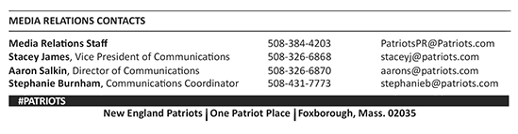
–PATRIOTS–

